VILNIUS GEDIMINAS TECHNICAL UNIVERSITY

FACULTY OF fundamental sciences
DEPARTMENT OF information systems

Somiparno Chattopadhyay

Applicant Scoring Model with Explanations and Fairness Mitigation

Master’s degree Thesis

Information Systems Software Engineering, state code 6211BX017
Informatics Engineering

Supervisor Dr. Algirdas Laukaitis

Consultant ______________________________________⁵ (Title, Name, Surname)

Consultant ______________________________________⁵ (Title, Name, Surname)

Vilnius, 2026

Contents
ABBREVIATIONS 4
INTRODUCTION 6
Investigation Object 7
Aim and Tasks of the Thesis 7
Novelty of the Topic 7
Relevance of the Topic 8
Research Methodology 8
Scientific Value of the Thesis 9
Main Results of the Thesis 9
Structure of the Work 9
Approbation of the work 10
1. RELATED WORKS ANALYSIS 11
1.1. Introduction to Multimodal AI 11
1.2. Document Intelligence 12
1.3. Vision-Language Modelling 13
1.4. Speech and Video Analysis 14
1.5. Multimodal Data Fusion 15
1.6. Answer Grading 17
1.7. Explanation of Student Profile Evaluation 18
1.8. AI Fairness 19
1.9. Summary of Related Works 20
2. PROPOSED METHOD AND SYSTEM DESIGN 27
2.1. Architectural Overview 27
2.2. Data Acquisition and the Artifact Tree 32
2.3. Perceptual Extraction Stages 33
2.3.1. Document Intelligence 33
2.3.2. Speech Transcription 33
2.3.3. Visual Context Anchoring and Description 34
2.3.4. Behavioural Analysis 35
2.3.5. Answer Grading 35
2.4. Multimodal Fusion 36
2.5. Scoring Model 36
2.6. Explainability 37
2.7. Fairness Mitigation and Human Oversight 37
2.8. Comparative Analysis of Candidate Technologies 38
2.9. Architectural Decision Record 41
3. INITIAL EXPERIMENTAL STUDY 44
3.1. Experimental Setup 44
3.2. Interview Grading (Sanity Check) 45
3.3. Scoring Conformance 45
3.4. Explainability Results 46
3.5. Fairness Analysis 47
3.6. Discussion and Threats to Validity 48
4. CONCLUSION 50
4.1. Further Works 50
5. REFERENCES 52

ABBREVIATIONS
AI: Artificial Intelligence
APA: American Psychological Association
EU: European Union
GPA: Grade Point Average
ML: Machine Learning
NLP: Natural Language Processing
CV: Computer Vision
LLM: Large Language Model
OCR: Optical Character Recognition
VLM: Vision Language Model
ASR: Automatic Speech Recognition
HITL: Human-In-The-Loop
BLEU: Bilingual Evaluation Understudy
MLM: Masked Language Modelling
MIM: Masked Image Modelling
MMM: Masked Multimodal Modelling
LBP: Local Binary Pattern
VQA: Visual Question Answering
CNN: Convolutional Neural Network
WER: Word Error Rate
LBP: Local Binary Pattern
BERT: Bidirectional Encoder Representations from Transformers
XAI: Explainable AI
SHAP: Shapley Additive Explanations
LIME: Local Interpretable Model-agnostic Explanations
DICE: Diverse Counterfactual Explanations
ROC: Receiver Operating Characteristic
AUC: Area Under the Curve
EER: Equal Error Rate
MFCC: Mel-Frequency Cepstral Coefficients
TDNN: Time Delay Neural Network
RAG: Retrieval Augmented Generation
ASAG: Automated Short Answer Grading
BPMN: Business Process Model and Notation
ADR: Architectural Decision Record
API: Application Programming Interface
GPU: Graphics Processing Unit
CPU: Central Processing Unit
GDPR: General Data Protection Regulation
JSON: JavaScript Object Notation

INTRODUCTION
Evaluation of applicant scores and past performance has been an ongoing problem to solve for universities, with new methods being developed over the years, as universities seek to identify candidates who sustain both dedicated effort to their academics and their necessary intellectual capacity. Students can be evaluated in a variety of ways, including but not limited to examinations, past academic records (Berhanu & Abera, 2015), a one-way or two-way video interview (Rasipuram et al., 2016), multiple-choice questions (Fahmi & Kahraman, 2017), or all of them.
While there are advantages to online interviews, there are clearly certain disadvantages. For one, the reviewers often perceive that they cannot gauge the actual calibre of the candidate. In a study where 81 candidates for a medical residency were surveyed, the results were mixed, with 62.9% applicants preferring in-person interviews (Moufarrej et al., 2025). However, a more significant issue arises in situations when there is a large pool of applicants and a limited number of reviewers; the reviewing process is often tedious, time-consuming and difficult to manage if there are time constraints for submission of feedback. An additional underlying issue concerns potential bias of a reviewer toward applicants based on factors such as geographical location, gender, or religious affiliation (Rieke & Bogen, 2018), or additionally, due to exhaustion or boredom (Erturk et al., 2022) that can impact mood, and hence applicant reviews. Applicant reactions to these automated, asynchronous video interviews are now studied directly. One review studies where such interviews help and where they fall short (Dunlop et al., 2025). A related study shows that the explanation given with an automated rejection shapes how applicants react (Falls et al., 2025), and that explanations raise fairness perceptions of AI selection even when a human decision is still judged fairer (Malin et al., 2025). AI-led interviews can also lower the intention to apply by reducing perceived procedural justice and organisational attractiveness (Luo et al., 2025), an effect others link to trust (Babaee & Shank, 2025). In response, a multi-stage design keeps human-resources staff in the loop and makes the AI's role transparent (Yuan et al., 2025).
More recent work continues to document these limitations: a 2026 study of asynchronous AI interviewers reports a persistent gap between what applicants expect from automated interviews and what such systems deliver and argues for designs that preserve applicant agency (Sakib et al., 2026).
There is a growing need for an automated multimodal solution to tackle these issues in an unbiased manner, that both evaluates applicant records and uses a combination of computer vision (CV), audio processing and natural language processing (NLP) to score a candidate’s profile. Multimodal systems have been used extensively in education, with literature surveys (Heilala et al., 2025) exploring different applications in academia that show their potential to enhance learning experiences through the integration of multiple interaction modes. Automatic grading is itself moving towards multimodal, language-model systems: one multi-agent framework scores essays across several quality facets (Su et al., 2025), another tests whether multimodal models can grade as good as expert instructors (Ibáñez et al., 2025), and a recent comparison weighs single-agent against multi-agent graders (Idowu & Almasoud, 2026). Their reliability is still being tested: agreement with human raters is strong in some higher-education studies (Gaggioli et al., 2025) and in rubric-based language grading (Yavuz et al., 2025), but a systematic review finds it varies widely across settings (Emirtekin, 2025).
The main research problem addressed in this thesis is therefore how to automatically and consistently score university applicants from multimodal evidence, e.g. academic records, documents and a recorded video interview, so that each admission decision is accurate, explainable to a human reviewer, and fair across demographic groups, while remaining compliant with the EU AI Act.

Investigation Object
The investigation object is a model to score and evaluate applicants for admission to a course in any university, given a video feed of the candidate’s interview and his/her credentials and past academic records.

Aim and Tasks of the Thesis
The aim of the research is to improve candidate assessment by exploring a multimodal AI-based model that automates the review of applicant records and assigns a metric to help decide the candidate's admission.
Tasks:
- To analyze and review existing research on design and implementation of multimodal models, data processing, and fairness or bias in applications with heavy reliance on Artificial Intelligence (AI).
- To propose an approach for multimodal verification of student documents, video interview analysis and evaluation of the student’s academic record.
- To implement a prototype of the proposed system and conduct an initial experimental study of its scoring accuracy, explainability and fairness on a controlled dataset, while remaining in compliance with the EU AI Act (European Union, 2024).

Novelty of the Topic
Student record evaluation is an ongoing problem to solve over the past decades, and the use of Artificial Intelligence (AI) and Natural Language Processing (NLP) to perform this task has been thoroughly explored by researchers and institutions. A paper by (Lui et al., 2022) discusses a method to grade student answers by a new approach of “divide-and-grade” clustering. The human grader’s task is to grade only one or two answers in each cluster, and the other answers in the same cluster are given similar grades. Another paper by (Ramani et al., 2024) uses three machine learning algorithms (Naïve Bayes, XGBoost and Ridge Regression) to train models on a dataset of questions and graded student answers to each question. The authors of the paper (Süzen et al., 2020) explore multiple approaches to automatically grade student answers and additionally provide feedback. In one approach, the authors found that there is a strong correlation between the human-assigned grades and the Hamming distance between the student response and the desired response. More recent work pushes this further: one study optimises how language models are prompted to grade student answers (Chu et al., 2026), another extends scoring to multimodal essays with decision-level ordinal modelling (Zhang et al., 2026), a third shows that rubric design and prompting can bias language-model scores (Kucia et al., 2026), and a fourth automatically refines the scoring rubric itself (Harada et al., 2025).

Relevance of the Topic
As universities face an ever-increasing pool of academic candidates for their studies, there is a need for an automated solution capable of consistent and unbiased grading of students’ profiles and performance after the academic interview. Some studies highlight concerns over an automated solution due to algorithmic bias (Obed Boateng & Bright Boateng, 2025) or AI-based decision making (Mehrabi et al., 2019). Our automated system will be relevant in the current scenario in that it will tackle most of the issues at hand and maintain public trust in university admissions. This problem is also relevant in scenarios where an evaluation of a candidate is necessary, for instance, in jobs, certifications or fraud detection. Studies show a positive perception of job applicants towards the application of AI in hiring systems (Hosain et al., 2025), and a reduction of workload for the recruiters (Chen, 2023), provided that proper bias mitigation, human monitoring and privacy practices are in place. Recent audits bear this concern out. Experimental evidence shows how biased hiring algorithms, and the methods meant to debias them, change the quality and diversity of those selected (Ip, 2025); competence and intersectional bias surface in AI resume screening (Webster, 2025); cultural bias appears in language-model hiring evaluations (Rao et al., 2025); and even subtle sociocultural cues in otherwise anonymised resumes still trigger demographic bias (Tan et al., 2026). In the admissions setting, recent work both measures and actively mitigates such bias in machine-learning admission models (Van Busum & Fang, 2025). The rapid spread of generative AI into admissions adds an equity concern of its own, with evidence of a digital divide in how applicants use large language models (J. Lee et al., 2026).

Research Methodology
The research uses a variety of methods to arrive at a conclusion. First, an analysis and review of existing research on multimodal models, video interviews, computer vision and natural language processing is performed. Afterwards, a model design for our proposed architecture of the evaluator pipeline is made. Afterwards, a prototypical model is implemented and evaluated on a controlled, synthetically generated dataset, and its scoring accuracy, explainability and fairness are assessed. Ultimately, the model's results are compared against the reference admission decisions of the dataset and its effectiveness is evaluated.

Scientific Value of the Thesis
This work aims to provide a framework for ethically and transparently evaluating candidate applications using a multimodal AI. The proposed architecture shows how computer vision and established large language models can be integrated with NLP systems to produce a testable and robust system for making academic decisions, since admitting the proper students may contribute to the betterment of academic institutions. The research also provides valuable insight into how multimodal models improve accuracy and fairness in admission without bias, designed to comply with applicable laws. This fits a wider shift towards interpretable, human-centred models for academic prediction and decision support (Guevara-Reyes et al., 2025; Swamy, 2025).

Main Results of the Thesis
The following results were obtained from our work:
- A detailed analysis of existing literature provided insight into the algorithms and methodologies used for multimodal applicant evaluation, fusion, explainability and fairness.
- The designed model was able to evaluate student applications and assign them a score.
- Because processing real applicant data would fall under the high-risk provisions of the EU AI Act, the prototype was evaluated in a simulated environment using a fully synthetic, labelled cohort. On this cohort the scoring model reproduced the reference admission decision with an accuracy of approximately 86% and an area under the ROC curve of 0.91.

Structure of the Work
The structure of the work onwards from Section 1 is discussed here. The first section provides a more detailed analysis of related works and builds a deeper insight by breaking down the problem statement at hand, along with papers related to the topic. The second section states the proposed approach and system design for fulfilling the aim and tasks of this thesis. The third section provides the implementation of the proposed approach and the results of the initial experimental study. The fourth section concludes this thesis and briefly discusses further works and future prospects of this topic. The fifth and final section lists all references used in this thesis in the APA 7th Style format.

Approbation of the work
The authors of this paper will participate in the 30th Conference of Young Scientists “Health and Information Systems of Information Technologies” in 2027, organized by Vilnius Gediminas Technical University (https://conferences.vilniustech.lt/index.php/SITIS/en).

RELATED WORKS ANALYSIS
This section focuses on providing a more detailed breakdown of the problem statement into different topics, analyzing multiple papers in each topic, after providing a brief introduction to the notion of a multimodal AI. This section draws inspiration from the FAIR-VID framework for fair evaluation of university applications (Laukaitis et al., 2025), which builds upon several domains of AI, namely: document intelligence, vision modelling, speech and video analysis, multimodal data fusion, answer grading, explanation of student profile evaluation and AI fairness under human supervision.

Introduction to Multimodal AI
A multimodal AI combines and analyses multiple forms of data pertaining to a topic simultaneously, to gain an optimal understanding of the topic (McKinsey & Company, 2025) and make accurate human-like predictions (Curtis & Kidd, 2024). Modern multimodal AIs are exemplified by GPT-5 (OpenAI Inc., 2025) and Claude Opus 4.5 (Anthropic PBC, 2025). In the context of applicant evaluation, multimodality is essential because academic performance is often expressed through different modalities (student documents, interview video and audio, academic grades) that must be interpreted together rather than separately.
In recent years, large multimodal models have been used to bridge vision, language and other modalities. For example, the technical report of OpenAI’s GPT-4 (OpenAI et al., 2024) explicitly describes GPT-4 as a large multimodal model which can accept image and text inputs and produce text outputs and exhibits enough human-level performance to perform several cognitive tasks, including passing a simulated bar exam with a score around the top 10% of the test-takers. The Gemini 2.X model family (Gemini 2.5 Pro and Gemini 2.5 Flash) has been described (Comanici et al., 2025) as excellent in multimodal understanding and can process up to 3 hours of video content.
Multimodal AI systems that employ contrastive learning effectively bridge the gap between images and textual input (Liang et al., 2025). Contrastive learning involves exposing unlabeled data points to a model in order to teach it which points are similar and which points are different by observing certain characteristics of different points. Contrastive learning approaches like ALIGN (Jia et al., 2021) use a dual-encoder architecture to process images and alternative texts that accompany an image, to generate visual and text embeddings respectively, and subsequently align matched image-alt text pairs closer to each other, while pushing those of non-matched pairs further from each other. Contrastive similarity scores provide enough data for the interpretation of a human’s interviewing abilities (people who could answer most questions are grouped together).

Document Intelligence
Document Intelligence refers to one of the various topics that are used for automatically ingesting and analysing information from textual documents, either digital or scanned from paper documents using Optical Character Recognition (OCR), i.e. parsing characters that are present in an image. This is particularly important in university admissions since universities need to evaluate academic performance from transcripts, marksheets and identification records.
Early breakthroughs in document intelligence like LayoutLM (Xu et al., 2020) shows that binding positional embeddings to text optimizes key-value extraction from structured data. More recently, models like Donut (Kim et al., 2022) leverage OCR-free approaches, treating document analysis as a direct image-to-text generation task. This method eliminates any intermediate steps in OCR, reducing errors in scanning and computational time. In higher educational institutions, systems for scanning documents often face difficulties in verifying the authenticity or contextual equivalence of documents across countries. To address this, the paper by (Laukaitis et al., 2025) involves Retrieval Augmented Generation (RAG) combined with vision-language reasoning. This enables the model to retrieve and assimilate data from various relevant sources, such as educational databases or accreditation lists.
Research has continued to expand these ideas with new multimodal document models. LayoutLMv3 (Huang et al., 2022) is designed to minimize discrepancies in learning features from text and images by treating both text and image inputs identically and subsequently using Masked Language Modelling (MLM) techniques to guess and reconstruct hidden words, and Masked Image Modelling (MIM) to guess hidden image tokens rather than raw pixels to focus on the overall document layout instead of the unnecessary details of the image. The model then predicts if an image patch corresponding to a specific word in the textual input is hidden and passes over all information to a multimodal transformer.
DocFormer (Appalaraju et al., 2021) also combines text, visual and spatial document features within a unified transformer and uses multi-modal self-attention to simultaneously process image, text and spatial streams, mapping shared spatial embeddings to both text and images in order to correlate a word with its corresponding visual appearance in the document. Since DocFormer can handle noise in image inputs, it can be used for scanning old or poorly printed documents as well.

Vision-Language Modelling
Vision-Language Models (VLM) are AI systems that integrate vision encoders with LLMs to process video and image inputs and provide an advanced understanding of those inputs. Models like CLIP (Radford et al., 2021) use zero-shot learning (the model observes data not foreseen during training and predicts that unforeseen data) of visual content. The model learns certain aspects of data from textual information and provided images, and as a result, has better recognition, semantic retrieval and captioning capabilities without direct supervision of unexpected data. In applicant evaluation, these models are crucial in evaluating video interviews by understanding audio and visual cues and help in testing the applicant’s veracity by tallying the applicant’s documents with their interview transcripts.
VLMs like BLIP-2 (J. Li et al., 2023) use a two-stage approach. In the first stage, it uses a Querying Transformer (alternatively called a Q-Former), which utilizes a small set of query vectors that extract the most important parts of an image. The Q-Former then passes on this information to “frozen” image encoders and LLMs, i.e. models whose original tuning parameters are not changed, saving significant computation costs and preventing the model from forgetting what they already understand. This is similar to models like Flamingo (Alayrac et al., 2022), which also leverages frozen pre-trained models to facilitate vision-language alignment without repetitive training costs. The perceiver resampler component of Flamingo is almost similar to the Q-Former in BLIP-2, generating the same number of visual tokens irrespective of the visual input resolution. However, while Flamingo incorporates these visual tokens by inserting trainable gated cross-attention layers between the existing layers of the language model, BLIP-2 keeps the LLM's architecture completely untouched and instead inputs the Q-Former's output as soft visual prompts. This design of BLIP-2 makes it significantly more efficient in terms of computational costs, enabling it to outperform Flamingo-80B on benchmarks while using 54 times fewer trainable parameters. Additionally, while Flamingo is primarily optimized for rapid adaptation through in-context learning with a small number of labelled inputs, BLIP-2 demonstrates better performance in instructed zero-shot image-to-text generation by reusing the abilities of frozen LLMs.
While VLMs offer powerful generational features, they are likely to suffer from hallucinations (H. Liu et al., 2024). The FAIR-VID paper (Laukaitis et al., 2025) mitigates this issue by verifying with time-synchronization and a combination of generative descriptions with layout metadata, due to which every AI-generated description can be traced back to a segment of a verified document or a video timestamp. The REVERSE framework (Wu et al., 2025) aims to reduce visual hallucinations by training a model to mark its own generated phrases with three special tokens, one for confident (</CN>), one for unconfident (</UN>) and one for marking the span of a phrase (<SPAN>), which enables the model to determine positions of uncertainty in the text, useful for backtracking and regenerating the output at those positions. Afterwards, the model applies rejection sampling at those positions, i.e. rephrasing those phrases, and query rewriting to fix the hallucinations.

Speech and Video Analysis
Speech and Video Analysis focuses on extracting behavioural information from a candidate that cannot be captured by textual data alone, such as fluency, confidence and speaker authenticity. In the context of university admissions, this information provides insight into an applicant’s communication skills and their honesty, which is a strong indicator of academic performance post-admission. This complements academic documents and assists in the holistic evaluation of the applicant.
Automatic speech recognition (ASR) and speaker verification have advanced through self-supervised learning. Several architectures such as wav2vec (Baevski et al., 2020) and HuBERT (Hsu et al., 2021), can detect emotions and generate transcriptions from audio data extracted from large unlabeled speech datasets. In practice, large-scale models trained on multilingual audio have set new standards in terms of speech analysis. OpenAI’s Whisper (Radford et al., 2022) was trained on 680,000 hours of diverse speech of different languages and accents; as a result, it often makes significantly lesser errors than specialized ASR models on varied real-world speech. Meanwhile, speaker recognition has benefitted from newer architectures like ECAPA-TDNN (Desplanques et al., 2020). Further models like EPCNet-TDNN (W. Li et al., 2025) build upon ECAPA-TDNN to report further gains.
For video analysis, models like the aforementioned ECAPA-TDNN (Desplanques et al., 2020) provide reliable speaker verification, and the openSMILE (Eyben et al., 2010) framework offers metrics for intonation and emotion in speech. Cross-modal deepfake detection is an active area in interview evaluation. For deepfake detection, approaches like LipForensics (Haliassos et al., 2021) can identify discrepancies between facial movements and speech. LipForensics learns how lip movements should align with speech using evaluations from the FaceForensics++ dataset (Rössler et al., 2019). LipForensics has successfully demonstrated greater performance against unseen deepfake generation methods by particularly focusing on lip motion and speech synchronization. It learns to lip-read on real videos, then flags discrepancies in deepfaked videos. Another aspect of video analysis for interviews is emotion detection, in order to detect a lack of confidence in answering questions, or possible fraudulent behaviour. A system built by (Chennoor et al., 2020) exemplifies emotion detection by perceiving video for reading facial expressions and audio for understanding voice modulation. Video processing involves using Local Binary Pattern (LBP), generating a mathematical map of the face and subsequently guessing an emotion from one of the six emotions (happiness, sadness, fear, disgust, surprise and anger), including a neutral state. LBP captures simple textural patterns in an image by comparing pixels to their neighbours, which helps in recognizing facial changes such as expressions or emotion. The voice analysis module listens for patterns in terms of loudness, pitch and disturbance or noise in audio signals by using MFCC (Mel-frequency Cepstral Coefficients) to mimic the functioning of a human ear. MFCCs are compact audio features that describe how a human ear would perceive sound by capturing the shape and tone of speech rather than raw audio waves.

Multimodal Data Fusion
The multimodal data gathered from various sources, after analysis, need to undergo fusion to be provided to a model as input. For applicant evaluation, improper data fusion may produce inaccurate results by prioritizing less significant parts of the candidate’s profile while underestimating others, e.g. an applicant stuttering in the interview may overshadow his stellar academic record.
Data fusion can either be early, late, or a combination of early and late fusion called intermediate fusion (Hangloo & Arora, 2025). Early fusion involves merging the features from different modalities into vectors before being processed by a model, while late fusion involves each unimodal feature being processed by separate models, and then aggregating the results afterwards using methods like averaging, voting or weighted sums (Figure 1.1). Intermediate fusion achieves a tradeoff between early and late fusion by combining features from different modalities at intermediate layers of a deep learning model, which allows complex cross-modal relationships to be captured in the model’s learning. Advancements in deep learning have introduced more sophisticated techniques to bridge the “heterogeneity gap” between different modes of data.
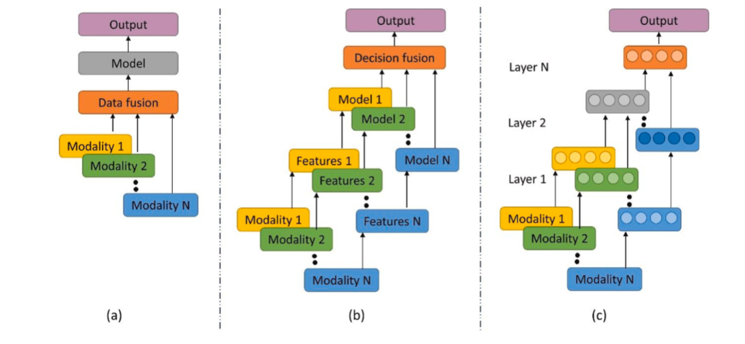
Figure 1.1: Techniques of multimodal fusion. (a) Early fusion, (b) Late fusion, (c) Intermediate fusion (Source: (Hangloo & Arora, 2025))
Attention-based models like Transformers (Vaswani et al., 2023) selectively focus on relevant portions of data while processing. Cross-attention between different modes of input is effective in multimodal fusion as it uses part of one modality of data as a “query” to look up “keys” and “values” in the other. Results show that such cross-attention processes often improve performance in vision-language modelling.
Facebook’s FLAVA (Singh et al., 2022) uses a transformer-based architecture consisting of three encoders to process multimodal information: one for image encoding, one for text encoding and the third for fusing the outputs of the former encoders and facilitating joint reasoning between visual and audio inputs. The model is trained through a joint pretraining scheme using both paired image-text data and standalone images and text. It is used for several objectives, some being maximizing the similarity of matched pairs across the batch, reconstructing masked image patches and text tokens, and prediction of a match between an image and text. FLAVA can be fine-tuned to categorize student profiles, score achievements, or perform Visual Question Answering (VQA) to answer specific questions about the contents of a student’s curriculum vitae.
Recent observations (Jiao et al., 2024) show that multimodal fusion must preserve important information while minimizing redundancy, since invalid fusion methods may introduce unnecessary noise and degrade the quality of results. However, a consensus is that intermediate fusion strategies manage the heterogeneity gap between different modalities efficiently while still exploiting rich joint representations.

Answer Grading
Automatic answer grading involves modelling semantic similarities between student responses in the interview and reference knowledge sources. Rather than relying on exact matches with the source, modern approaches aim to mimic human grading behaviour by clustering techniques or distance matches. For university admissions, a proper automatic grading model assists admissions officers assess an applicant’s domain knowledge and reasoning in a scalable manner and also eliminates fatigue during high-volume scenarios.
The paper by (Lui et al., 2022) discusses an approach to grading student answers by effectively dividing the answers into clusters, where each answer in a cluster receives a similar grade. The authors propose a novel approach to the grading framework, consisting of the following components:
- A model for representing the given short answers in a machine-friendly form.
- A multi-objective evolutionary algorithm for clustering.
- A method for using actual grades given by human graders to be provided to the model for clustering improvements
- A method for selecting the most effective answers for grading
- A method for dividing the answer set into clusters
The evolutionary algorithm involves finding a set of optimal solutions by initially preparing a random solution, then replacing the solutions over time with better solutions, using repeated mutations and crossovers. The optimal solutions are called Pareto optimal solutions, in which one objective cannot be optimized without worsening the other. Cluster compactness (how data points are linked to their nearest neighbours within or across clusters) and cluster connectivity (how tightly connected each data point is to other points in the same cluster) were used as objectives to be optimized. Since these two objectives are conflicting, a Pareto optimal solution represents the best possible tradeoff between those two objectives.
Another paper by (Süzen et al., 2020) discusses a separate approach, using a corpus of student responses from an introductory computer science exam. After cleaning and stemming the data corpus, the responses are converted to numeric vectors using a Bag of Words model. Afterwards, a mathematical model based on the Hamming distance (Hamming, 1950) between model answers and student responses is proposed, which is calculated by counting how many required words are missing from the student response. A high correlation between Hamming distance and marks awarded by human graders was found.
A paper by (Bonthu et al., 2024) addresses the scarcity of domain-specific data for ASAG by utilizing unlabeled sources, e.g. textbooks to inject contextual knowledge into models. The methodology involves pre-training of a DistilBERT architecture from scratch or via enhancement and subsequently fine-tuning the model with a small amount of labelled data using Siamese networks (i.e. networks with two or more identical child networks that can process different inputs parallelly to optimize a similarity metric) which accomplishes an accuracy of 88.77%.
The reliability of the grader itself has become a focus of recent work: a 2026 study calibrates confidence estimates to decide when an LLM grader can be trusted (Ferrer et al., 2026), while another models grading accuracy as a function of grader ability and response difficulty through item response theory (Cong et al., 2026).

Explanation of Student Profile Evaluation
Explainable AI (XAI) aims to make automated decisions understandable to human stakeholders and supervisors. In student profile evaluation, explanations are key to maintaining trust, conforming to regulatory policies, ensuring fairness, and to address any bias.
The authors of the paper (Rico-Juan et al., 2025) discuss the development of an ML-based recommendation system that aligns high-school student profiles with appropriate bachelor's degree programs. The recommender was trained on approximately 72000 pre-university student profiles from a Spanish university. Subsequently, it uses Shapley Additive Explanations (SHAP) to attribute features and explain its recommendations (e.g. showing how taking Geography may reduce the chance of recommending Computer Science). SHAP leverages game theory by treating every feature in a model as a “player” in a game and a prediction of the model as a “reward”, then distributing the reward fairly among all the players in the game. This can be used to explain a human supervisor as to which part of a student’s profile contributed most to their evaluation, and which parts contributed the least.
Another paper (Raftopoulos et al., 2024) focuses more on the transparency of the decision-making process. Decision trees and logistic regression models were trained on structured applicant data consisting of GPA, demographics and test scores to predict the results of an admission evaluation. Importance scores from decision trees are useful in explaining how each feature of a profile (GPA, test scores, etc.) affected the probability of admission, e.g. a low GPA will drastically reduce the chances of admission, while work experience may increase the chances. Included with the model’s decisions are rule-like explanations that admissions officers can examine to discuss and reach a final decision.
The work of (Johora et al., 2025) uses both SHAP and Local Interpretable Model-agnostic Explanations (LIME) techniques. LIME is an explanatory algorithm that can be used on any AI model (that it treats as a “black box”) by selecting one instance of an input, generating several slightly modified variants of that instance, feeding the instance and its variants to the model, building a simplistic variation of the model based on the model’s predictions then using its weights as the explanation. This work focuses more on predicting a student’s performance while studying in a university, in terms of end-of-semester grades. The authors designed an ensemble model combining multiple ML algorithms, then employed both SHAP and LIME approaches to explain the model’s outputs. The SHAP analysis identified trends in global features that were affecting the student’s grade (e.g. prior grades, attendance) while LIME provided explanations for grades on a student-wise basis. As a result, the admissions council can see which factors contributed to a particular student’s admission (using LIME) or a summarized explanation (via SHAP).
Another paper (Afzaal et al., 2024) explores a new algorithm named Diverse Counterfactual Explanations (DICE). A counterfactual is a hypothetical version of a particular input where the outcome of the input is different, while changes are minimal and can be realistically achieved, e.g. what would the chances of admission be if the final grade in his bachelor's degree was 0.3 higher? DICE involves generating multiple counterfactuals, then the most probable counterfactual that correlates the most (if each counterfactual is equally likely) with the student’s profile is selected. This approach helps in providing clear instructions for the student to improve their profile to increase their likelihood of admission.

AI Fairness
As AI systems touch sensitive domains such as candidate evaluation, fairness and bias mitigation are paramount. Bias in AI models can arise from demographic imbalance in data, data quality, or environmental context. Studies by (Mehrabi et al., 2019) and (Chin-Purcell & Chambers, 2021) highlight significant disparities across gender, ethnicity, and linguistic groups in facial and speech recognition systems. In multimodal systems, bias may compound across different modalities, which warrants a requirement for governance frameworks. FAIR-VID addresses these issues by employing human-in-the-loop design and explainable outputs. The FAIR-VID model also aligns with the EU AI Act’s requirements by processing applicant data right on the fly.
A survey by (N. Lee et al., 2023) emphasizes that even vision-learning models suffer from inadvertent encoding of racial, gender or ethnic stereotypes from their multimodal data. A multidimensional analysis of pretrained English Vision-Language models (Ruggeri & Nozza, 2023) revealed that those models generate insulting completions for approximately 5% of the time when presented with images of people with different ethnicities, and the insults were more pronounced for female and young subjects. A test was introduced to detect similar biases in tasks like VQA. Observations from the test results confirm that these models perpetuate associations of people with stereotypes and linking specific social groups to concepts like “career”, “family” and “unpleasant”. Additionally, a more diversified dataset with similar proportions of each ethnicity contributes to lesser bias and association of negative stereotypes.
Recent multimodal work shows that such disparities can persist even when explanation methods are applied: a 2026 study of vision-language models for wellbeing assessment reports measurable fairness gaps that explainability alone does not close (Chiang et al., 2026).
The European Commission has published a white paper (European Commission, 2020) proposing a strategy to develop an ecosystem of excellence through coordinated investment and an ecosystem of trust grounded in a new regulatory framework. This framework adopts a proportionate and risk-based approach that mandates strict requirements for high-risk AI applications to protect fundamental rights, privacy and safety while ensuring legal certainty for innovation.

Summary of Related Works
The following table summarizes the key research streams, methodologies, and trends identified in the literature. The table contains the following columns:
- “Reference” identifies the primary academic source corresponding to the referenced work.
- “Used Approach” describes the core algorithm or methodology implemented in the referenced work.
- “Problem Domain Studied” specifies the research problem addressed by the study.
- “Dataset Used” denotes the dataset that was used, along with the source, for training models in the study, if applicable. This column usually does not contain any dataset information for literature surveys.
- “Attributes used for Prediction” details the key features used to make predictions with the model.
- “Evaluation of the Approach” lists the metrics, validation methods or evaluation strategies used to assess the performance of the model using qualitative or quantitative measures.
- “Main Result” summarizes the primary observations, highlights or contributions of the work that can be relevant for developing our system.
Table 1.1 Summary of related works referenced for candidate evaluation
Reference | Used Approach | Problem Domain Studied | Dataset used | Attributes Used for Prediction | Evaluation of the Approach | Main Result
(Xu et al., 2020) | Transformer-based document model with text, layout, and visual embeddings | Document intelligence, key-value extraction | FUNSD (Jaume et al., 2019) | Text tokens, 2D positional embeddings, visual features | F1-score on form understanding and document classification tasks | Demonstrated that incorporating layout information significantly improves document understanding performance
(Kim et al., 2022) | OCR-free vision-to-text Transformer | Document understanding without OCR | CORD (Park et al., 2019), DocVQA (Mathew et al., 2021) | Raw document images | Exact match accuracy, end-to-end latency | Achieved competitive or superior accuracy while reducing OCR-induced errors and computational complexity
(Radford et al., 2021) | Contrastive vision-language pretraining | Vision-language alignment, zero-shot classification | Custom dataset named WebImageText (400M image–text pairs) | Image embeddings, text embeddings | Zero-shot accuracy on ImageNet and downstream tasks | Enabled robust zero-shot image recognition without task-specific fine-tuning
(H. Liu et al., 2024) | Analytical study of hallucination in VLMs | Reliability and robustness of VLM outputs | Multiple public multimodal benchmarks | Generated captions, grounding consistency | Qualitative and quantitative hallucination metrics | Identified hallucination as a major risk in generative vision-language systems
(Laukaitis et al., 2025) | Multimodal pipeline with RAG, VLMs, HITL | Fair university admission evaluation | IELTS Certificates | Document entities, video frames, audio features, metadata | Precision, recall, expert validation | Improved fairness, traceability, and robustness in admission preprocessing
(Baevski et al., 2020) | Self-supervised speech representation learning | Automatic speech recognition | Librispeech (Panayotov et al., 2015) | Raw audio waveforms | Word error rate (WER) | Achieved near state-of-the-art ASR with limited labeled data
(Eyben et al., 2010) | Handcrafted acoustic feature extraction | Speech emotion and paralinguistics | No datasets mentioned | Prosodic, spectral, energy features | Classification accuracy | Established a standardized toolkit for speech emotion analysis
(Desplanques et al., 2020) | Deep neural speaker embedding model | Speaker verification | VoxCeleb (Nagrani et al., 2017) | Spectral and temporal speech features | Equal error rate (EER) | Improved speaker verification robustness over x-vector models
(Haliassos et al., 2021) | Cross-modal lip–speech consistency learning | Deepfake video detection | FaceForensics++ (Rössler et al., 2019) | Lip motion, speech synchronization | Detection accuracy, generalization tests | Achieved strong generalization against unseen deepfake generation methods
(Hangloo & Arora, 2025) | Survey of fusion techniques | Multimodal learning architectures | No dataset – Literature Survey | Multimodal feature representations | Comparative qualitative analysis | Identified intermediate fusion as a balanced and effective strategy
(Vaswani et al., 2023) | Attention-based neural architecture | Sequence modeling and multimodal fusion | WMT (WMT-SLT, 2014) | Token embeddings, attention weights | BLEU score, downstream task metrics | Enabled scalable cross-modal attention and contextual learning
(Lui et al., 2022) | Evolutionary clustering for grading | Automated short-answer grading | Proprietary custom student answer datasets | Text embeddings of student responses | Correlation with human grades | Achieved grading consistency comparable to human evaluators
(Süzen et al., 2020) | Distance-based grading (Hamming distance) | Automated exam evaluation | Custom dataset – Introductory computer science exam corpus | Bag-of-Words vectors | Correlation coefficient with human scores | Demonstrated strong alignment between lexical similarity and human grading
(Mehrabi et al., 2019) | Survey of bias in ML systems | Algorithmic fairness | Literature survey – Multiple datasets e.g: ImageNet(Deng et al., 2009), IJB-B (Whitelam et al., 2017) | Demographic attributes | Bias taxonomy and risk analysis | Highlighted systemic sources of bias in AI pipelines
(Chin-Purcell & Chambers, 2021) | Bias analysis in speech and vision AI | Ethical AI assessment | IMDb (Rothe et al., 2018) | Gender, accent, ethnicity markers | Disparity analysis | Identified measurable demographic bias in deployed AI systems
(Appalaraju et al., 2021) | Multi-modal Transformer (DocFormer) with novel multi-modal self-attention fusing text, vision, and spatial features | Document understanding (form and receipt extraction) | FUNSD (Jaume et al., 2019), Kleister-NDA (Graliński et al., 2020), CORD (Park et al., 2019), RVL-CDIP (Harley et al., 2015) | Text tokens, 2D spatial embeddings, ResNet-50 visual features | F1-score on entity labeling and document classification | Achieves state-of-the-art on all evaluated document tasks, outperforming larger models
(Huang et al., 2022) | Unified multimodal pretraining (LayoutLMv3) with combined text/image masking and word-patch alignment | Document AI (form understanding, VQA, classification) | FUNSD (Jaume et al., 2019), CORD (Park et al., 2019), RVL-CDIP (Harley et al., 2015) | Text tokens and image patch embeddings | Task-specific metrics (F1, accuracy) on document tasks | State-of-the-art performance on multiple document-centric and image-centric tasks
(Jia et al., 2021) | Contrastive dual-encoder aligning image and text representations using web-scale noisy alt-text data | Vision–language representation learning | Dataset of 1 billion+ noisy alt text-image pairs based on Conceptual Captions dataset (Sharma et al., 2018) | Image encoder features; text encoder embeddings | Zero-shot ImageNet accuracy | Strong zero-shot classification and retrieval, setting new state-of-art in vision–language tasks
(Alayrac et al., 2022) | Visual language model (Flamingo) combining frozen vision and language backbones via cross-attention | Few-shot vision-language learning (VQA, captioning) | MassiveWeb dataset (Rae et al., 2022) | Raw images/video frames and text prompts | Few-shot accuracy on VQA and captioning benchmarks | New state-of-the-art in few-shot multimodal tasks, often outperforming fully fine-tuned models
(J. Li et al., 2023) | Efficient VL pretraining (BLIP-2) with frozen image encoder and language model connected by a Querying Transformer | Vision-language tasks (e.g., VQA, captioning) | LAION-400M (Schuhmann et al., 2021) | Image embeddings from CNN | Zero-shot VQA accuracy; caption generation quality | State-of-the-art on many VL tasks with far fewer trainable parameters (e.g., +8.7% on VQA vs Flamingo-80B)
(Wu et al., 2025) | Hallucination-aware training with on-the-fly self-verification (REVERSE) using retrospective resampling | Reducing hallucinations in vision-language models | Custom dataset – Semi-synthetic instruction tuning dataset for hallucination aware training. | Image content and generated captions | Hallucination detection and reduction metrics on CHAIR-MSCOCO (Rohrbach et al., 2018), HaloQuest (Z. Wang et al., 2024) | New state-of-the-art in reducing hallucinations (up to 12% improvement on CHAIR-MSCOCO, 34% on HaloQuest)
(Hsu et al., 2021) | Self-supervised speech model (HuBERT) with masked prediction of hidden speech units | Speech representation learning (ASR) | LibriSpeech (Panayotov et al., 2015) | Raw audio waveforms | ASR word error rate (WER) on Librispeech | Matches or surpasses wav2vec 2.0, showing up to 19% word error rate (WER) reduction on challenging subsets
(Radford et al., 2022) | Large-scale ASR (Whisper) trained on vast multilingual audio-transcript data | Robust speech recognition | Custom Dataset - 680,000 hours of labeled audio data collected from the internet | Raw audio waveforms | Zero-shot WER on multilingual ASR benchmarks | Approaches human-level transcription accuracy; generalizes across many languages and tasks
(W. Li et al., 2025) | TDNN with Efficient Channel Attention (EPCNet-TDNN) and enhanced residual blocks | Speaker verification | VoxCeleb1 (Nagrani et al., 2017), (Fan et al., 2019) | Acoustic features (e.g., MFCC) | Equal Error Rate (EER), Minimum Detection Cost Function (minDCF), accuracy | Outperforms standard ECAPA-TDNN, achieving higher accuracy and lower EER across datasets
(Chennoor et al., 2020) | Multimodal emotion classifier using Local Binary Pattern (LBP) on video and MFCC on audio | Human emotion detection (audio + video) | Custom interview video dataset (audio+video) | LBP facial descriptors; MFCC audio features | Emotion classification accuracy (6 emotion classes) | Demonstrated that combining audio and video features improves emotion recognition accuracy
(Singh et al., 2022) | Unified multimodal pretraining (FLAVA) with both contrastive and generative objectives | Foundational vision-language representation | Wikipedia Image-Text dataset (Srinivasan et al., 2021), ImageNet challenge (Russakovsky et al., 2015) | Image patches and text tokens | Performance on around 35 vision and language tasks | Strong performance across vision, language, and multimodal benchmarks
(Jiao et al., 2024) | Survey of deep learning multimodal fusion methods (early, late, hybrid) | Multimodal data fusion | No dataset – Literature Survey | No training – Literature Survey | Qualitative analysis of multimodal fusion strategies | Emphasizes preserving complementary information and reducing redundancy; identifies mid-level fusion as effective
(Bonthu et al., 2024) | Domain-adaptive pretraining for ASAG: pretrain language model on unlabeled domain corpus, then fine-tune | Automated short answer grading | Short Programming-Related Answer Grading dataset (Bonthu et al., 2025) | Student answer text | Accuracy and F1 | Achieved 88.77% accuracy and 91.59% F1 (4–5.7% above prior state-of-the-art model) by leveraging domain-specific pretraining
(N. Lee et al., 2023) | Survey of social biases in vision-language models | Vision-language fairness | No dataset – Literature Survey | No training – Literature Survey | Qualitative bias analysis in vision language models | Highlights that vision language models inadvertently encode racial, gender, and ethnic stereotypes from training data
(Ruggeri & Nozza, 2023) | Fairness and bias analysis in vision language models | Vision-language fairness (gender, ethnicity, age) | Custom bias evaluation sets (visual templates, VQA questions) | Images of people with demographic labels | Biased word completion rates; VQA bias metrics | Found pre-trained vision learning models frequently generate hurtful outputs (e.g. 5% for neutral prompts, especially targeted towards women and young people), indicating biases in downstream tasks.
(Rico-Juan et al., 2025) | Machine learning based recommenders using SHAP explainability. | Explainable student profile evaluation and degree program recommendation | 72000 samples of student data from an anonymous Spanish university | High-school subjects, grades, academic background | Recommendation accuracy, SHAP-based feature attribution analysis, bias inspection | SHAP explanations provided transparent, human-understandable insights into academic recommendations and revealed latent biases in learned patterns.
(Raftopoulos et al., 2024) | Interpretable machine learning models (logistic regression, decision trees, ensembles) | Transparent and fair university admission prediction | MBA Admission Dataset (Lo, 2025) Law School Dataset (Wightman, 1998), College Admissions Dataset (Qian, 2018) | GPA, standardized test scores, demographic indicators, academic history | Prediction accuracy; demographic parity and equalized odds fairness metrics | Demonstrated that explainable models can achieve competitive admission prediction performance while enabling rule-based, inspectable explanations.
(Johora et al., 2025) | Ensemble model with SHAP and LIME explanations | Explainable student performance prediction | Undergraduate student dataset from Bangladesh | Attendance, prior grades, coursework scores, academic behavior indicators | Prediction accuracy; SHAP global importance; LIME local explanations | Combining ensemble learning with SHAP and LIME improved predictive performance while providing transparent global and instance-level explanations suitable for educational decision support
(Afzaal et al., 2024) | Counterfactual explanation framework using DICE (Diverse Counterfactual Explanations) | Explainable student performance and outcome prediction | Custom dataset constructed using data from students in Stockholm University | Study behavior metrics, academic engagement indicators, assessment scores | Validity, proximity, and diversity of generated counterfactuals; qualitative interpretability analysis | Generated actionable, human-understandable counterfactual explanations that transform black-box predictions into personalized guidance, supporting transparency and fairness in student evaluation
As can be summarized from Table 1.1, most of the reviewed studies rely on transformer-based and multimodal deep learning architectures, with frequent appearances of contrastive learning (Jia et al., 2021) and self-supervised techniques (Baevski et al., 2020; Hsu et al., 2021), while classical machine learning tasks are mostly limited to automated short answer grading (Lui et al., 2022) and emotion detection (Chennoor et al., 2020). The problem domains mostly involve document intelligence, vision-language modelling and analysis of speech and video. The works pertaining to Explainable AI mostly explore SHAP to explain student evaluation. A smaller but significant subset of works addresses bias and fairness in AI-based systems (Ruggeri & Nozza, 2023). Relevance to the real world in some studies is exemplified by training and evaluating models on public benchmark datasets (Whitelam et al., 2017). Prediction attributes commonly combine text, audio and visual features, while evaluation is predominantly quantitative, using metrics such as accuracy (Bonthu et al., 2024; Huang et al., 2022), F1-score (Huang et al., 2022) and WER (Baevski et al., 2020).

PROPOSED METHOD AND SYSTEM DESIGN
This chapter states the key propositions of the work and the formal design of the method. The system is a digital twin of a university admissions desk [CITE: Grieves and Vickers, 2017] which is a software copy of the process in which an applicant submits a case, documents are read, an interview is reviewed, and a decision is issued. The copy is a set of agents. Each agent performs one task, reads one event stream, and publishes the next event. Agents do not call one another. The event log is the record of what the system believed at each step [CITE: Kreps, Narkhede and Rao, 2011]. Each agent also writes its output into a shared artifact tree and does not overwrite another agent's files. The split between events and files enables every intermediate result to be observable. The design serves the transparency duties that the EU AI Act places on high-risk systems and follows the trackable human-in-the-loop philosophy of the FAIR-VID framework (Laukaitis et al., 2025).
The case-level control flow is specified in two equivalent notations. As a business process it is a BPMN collaboration [CITE: Object Management Group, 2014]: one pool for the admissions case, one lane per actor, and parallel gateways where branches start and meet. As a UML activity it is the same flow with fork and join nodes and one partition per actor [CITE: Object Management Group, 2017]. There is no exclusive gateway on the outcome. Admitted and rejected applicants follow the same path and receive the same kind of letter. The stage diagrams already embedded in this chapter were drawn in Camunda (Camunda Services GmbH, 2024) for the earlier file-only pipeline. They remain the right pictures of the individual perception tasks. Where the control flow has changed, they should be redrawn from the gateways in this chapter. Sequence diagrams of the running system were produced with Mermaid (Sveidqvist, 2024). The earlier context, container and component views were produced with PlantUML (Roques, 2024).

Key Propositions
The design rests on five propositions. They fix what the system claims. The rest of this chapter is the method that realises them.
Proposition 1. An admissions case can be copied as a digital twin: one agent for each task at the desk, coordinated only by events, with the file tree kept as evidence rather than as the means of calling the next step.
Proposition 2. The admission score is a late fusion of interpretable summaries. It is released when eligibility, the transcript grade, prosody, face behaviour and the frame description are all present. The reconciliation vote is an audit. It does not gate the score.
Proposition 3. Identifiers are removed at the document-summary step. Any later model, including a model reached over a network, sees that summary and the interview features, not the passport scan and not the identity fields of the raw recording.
Proposition 4. The score is a logistic function of a fixed feature vector. Academic features may explain a decision, but a counterfactual, and the letter to the applicant, may propose changes only to interview features. Grades already on file are not rewritten.
Proposition 5. Fairness is a measured property of the score against a protected attribute that is never itself a feature. Mitigation may drop a proxy feature or set a threshold per group. A person reads the explanations before the outcome is treated as the university's decision.

Architectural Overview
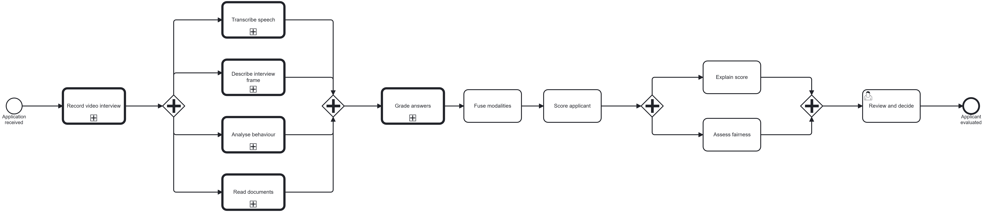
Figure 2.1: End-to-end processing pipeline (BPMN). The embedded drawing is the earlier file pipeline. Redraw its parallel gateways to match equations (2.1) and (2.2).
The case is one BPMN pool. The lanes are the applicant, intake, the document agents, the interview agents, evaluation, notification, and the progress manager. The applicant submits the application. Intake opens the case, and a parallel gateway starts four branches at once: document reading, audio extraction, face behaviour, and the frame description. There is no exclusive gateway afterwards. The same tasks run whether the score will fall above or below one half.
Three further parallel gateways sit inside those branches. After the anonymised document summary, one branch reconciles model summaries and the other checks eligibility. Only eligibility continues to evaluation. After the audio track is extracted, one branch transcribes the speech and then grades the answer, and the other measures prosody. Those two meet before evaluation. The evaluation converging gateway waits for five tokens: eligibility, the transcript grade, prosody, face behaviour, and the frame description. Scoring runs only then. Notification sends one letter, of the same kind for every outcome, naming the decision, the score, and the interview points that are still weak. A second converging gateway, the one that closes the case, waits for that letter and for the reconciliation audit. The progress manager follows the same rule. Staff can ask it which stages have finished. It does not score the applicant. This is the messaging style in which the agents are the endpoints and the log is the pipe [CITE: Hohpe and Woolf, 2003].
Each agent reads one topic and publishes the next. A copy of every completion is also published on a progress topic, which is how the manager updates the case file, and that copy is not an extra task in the business process. Subjective judgements, such as a scene description or a grade, are stored as text or JSON under the applicant's folder. A later agent reads that artifact. It does not re-run the model that produced it. Without a broker, the same handlers can run in one process and write the letter to a local outbox. That is the path used when the demonstration is run on a single machine.
The evaluation gateway and the gateway that closes the case are the sets below. A stage name denotes the event that says that stage has finished for this applicant.
$J_eval = \{eligibility, grade, prosody, behaviour, frame\}$ (2.1)
$J_close = J_eval ∪ \{reconciliation, notification\}$ (2.2)
Scoring is enabled only when every member of J_eval has arrived. The case is marked complete only when every member of J_close has arrived. Reconciliation is in the second set and not in the first, which is the formal statement of Proposition 2.
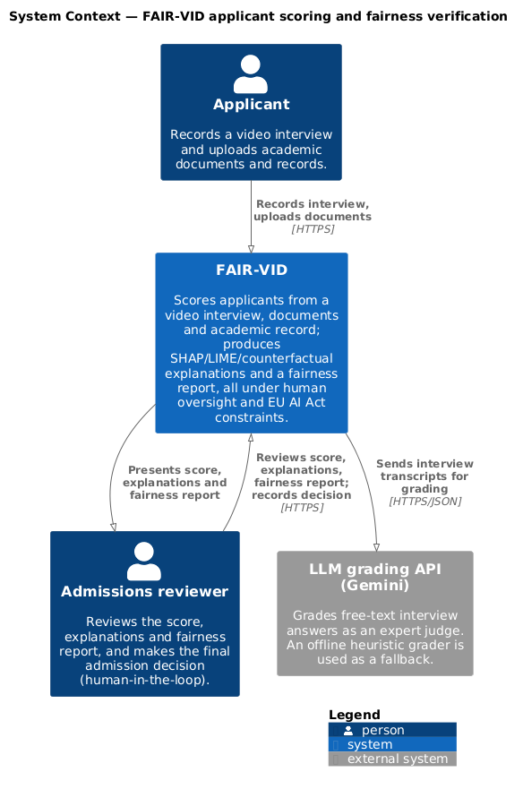
Figure 2.2: System context (C4 model). Extend the drawing with the progress manager and the notification agent.
In the context of the running system, an applicant submits a case and, in the live demonstration, records the interview in the browser. Staff may ask the progress manager how far that case has got, either over HTTP or by a request on the manager topic. When evaluation finishes, the notification agent emails the applicant. A human reviewer still sees the score, the explanations and the fairness report before the outcome is treated as the university's decision. Free-text answers are graded by a language model acting as a judge, with an offline grader when that service is absent.
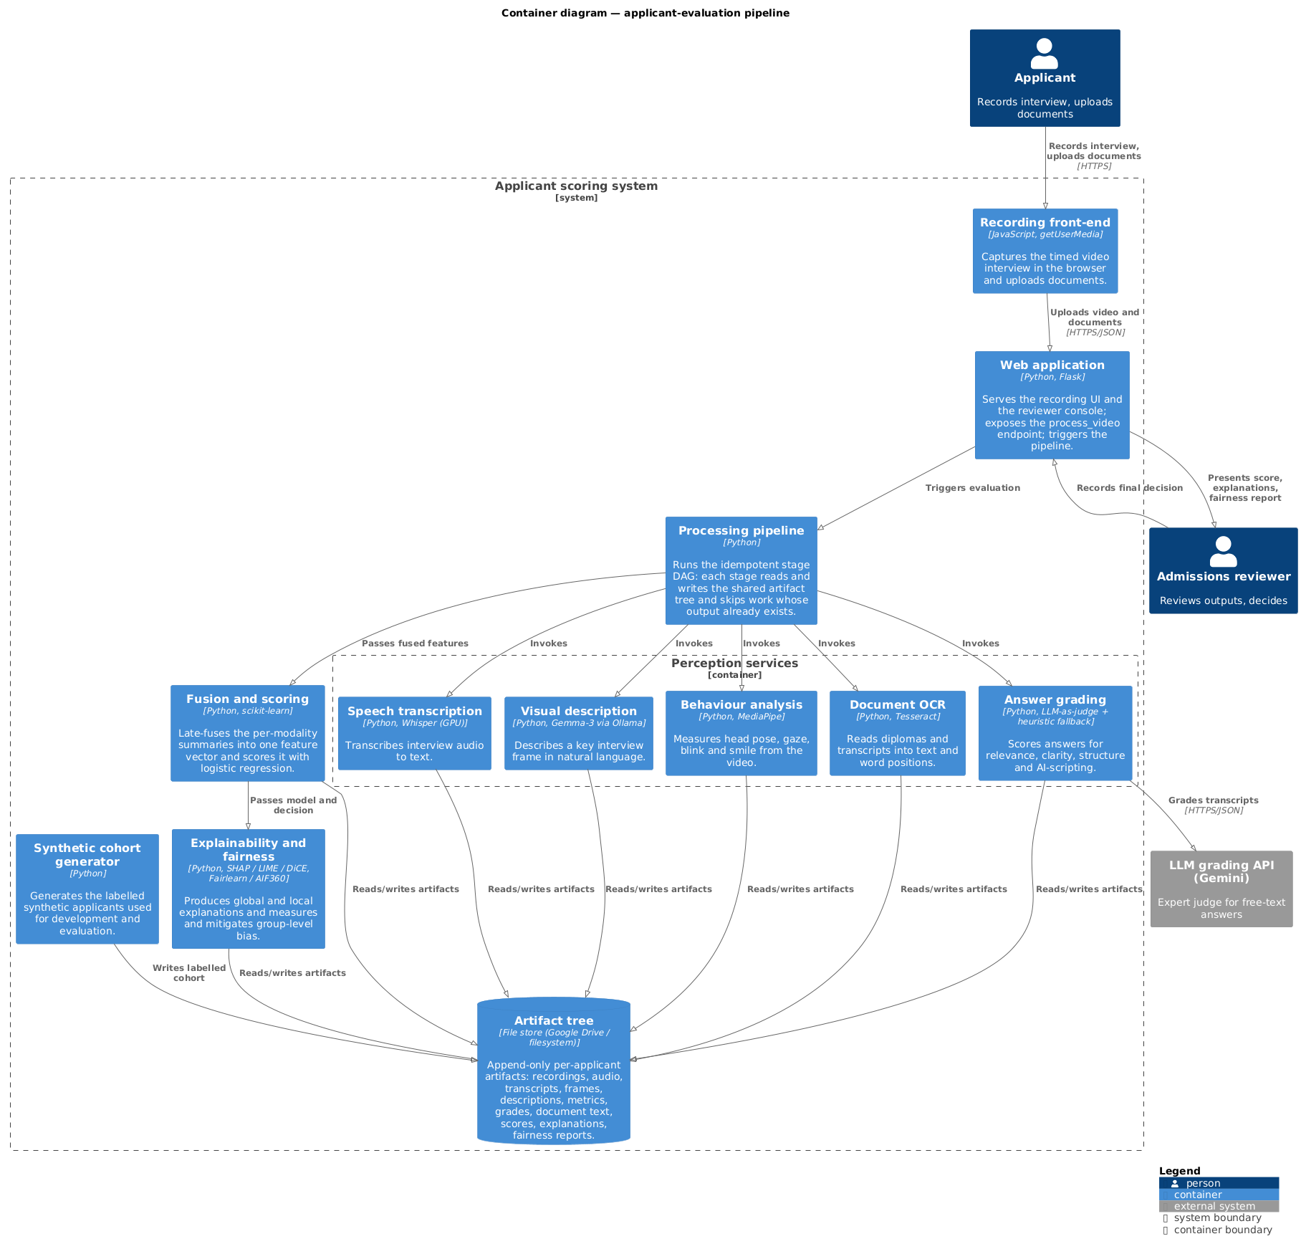
Figure 2.3: Container view (C4 model). Add the event log beside the artifact store.
The containers are the browser, the web application, the agent processes, the event log, the artifact store, the scorer, and the explanation and fairness checks. The log carries control. The artifact store carries evidence. A generator still builds the synthetic cohort used while real records cannot be processed. The embedded container drawing predates the log and should gain a broker, a progress manager, and a notification agent.
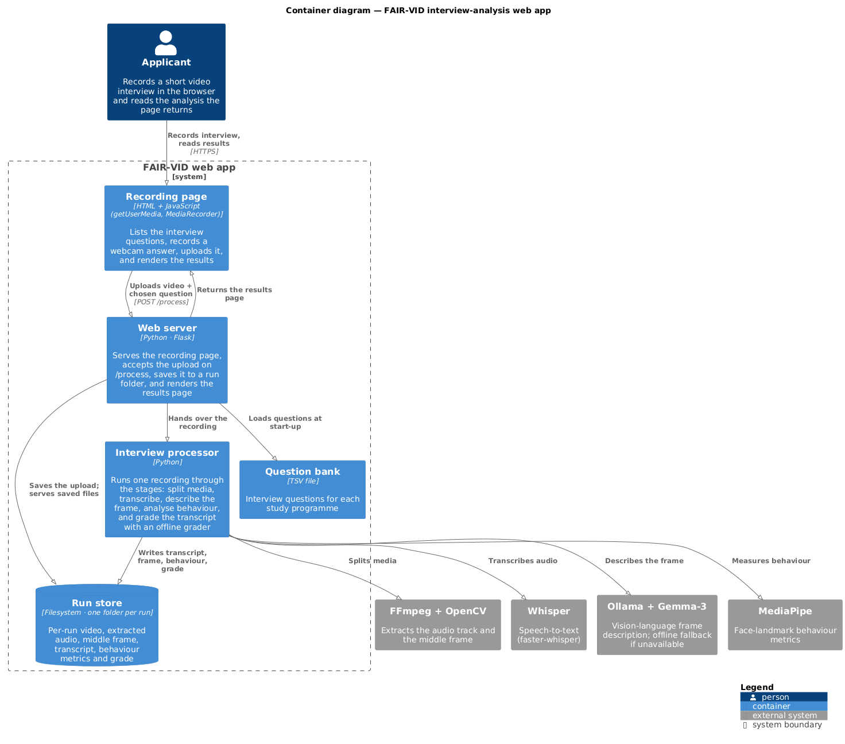
Figure 2.4: Web-app container view (C4 model). This path is the interview track for one pre-loaded candidate.
The live demonstration is narrower than a full case. One candidate is already loaded, with the diploma and the academic numbers on disk, and the session only records the interview. The browser posts the recording to the server, which extracts audio, transcribes it, describes one frame, measures the face, grades the words, and, when the audio library is present, measures prosody. Those live features are joined to the academic numbers already on file. The page then shows the admission probability and the SHAP, LIME and counterfactual views. A large speech-emotion network is left unloaded unless it is explicitly switched on. If the local vision model is not running, the frame description is a short offline sentence marked as such.
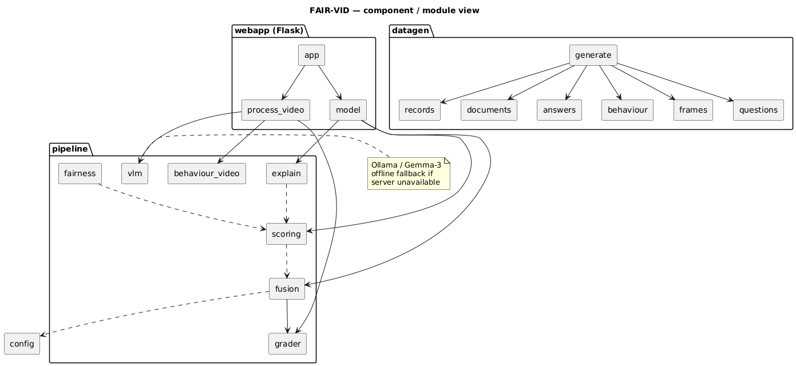
Figure 2.5: Software components of the system. Arrows mean 'reads the artifact of', not a direct call.
The code follows the same split as the agents. One part generates the synthetic cohort. One part holds perception, fusion, scoring, explanation and fairness. One part is the web application. A further part is the event layer: topic names, one consumer per topic, the join, the letter, and the progress manager. The component drawing should be read with that rule. Replacing an agent means replacing the program that consumes its topic, not rewiring a call graph.
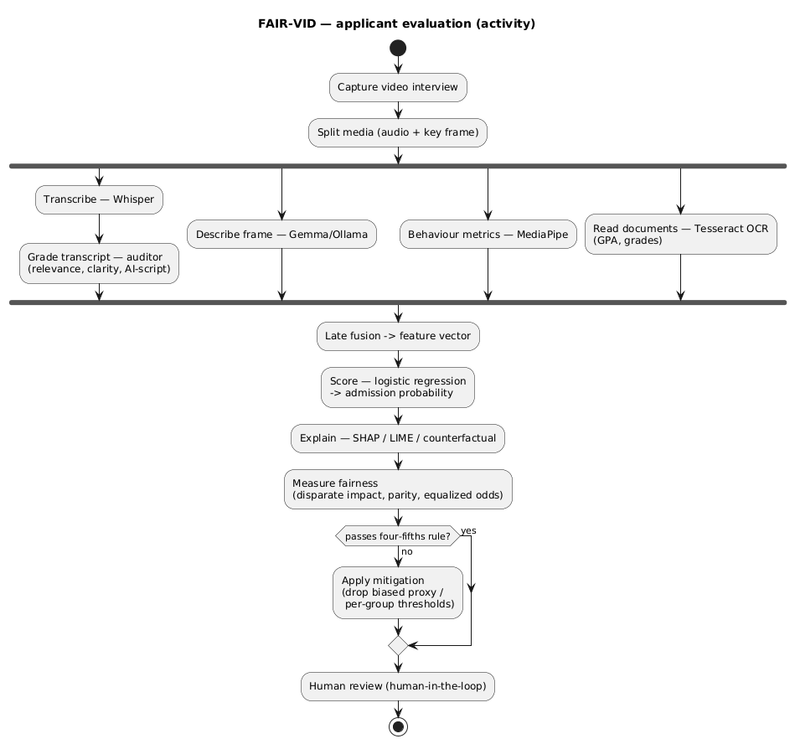
Figure 2.6: Activity flow of an applicant's evaluation. Redraw as a UML activity with the forks and joins in this section, and with no decision node on the outcome.
Read as a UML activity, the case has one initial node and one activity final node. After the case is opened, a fork starts document reading and the three interview branches. The summary fork starts reconciliation and eligibility. The audio fork starts transcription-and-grading and prosody. The evaluation join is late fusion: the scorer never receives the raw video or the raw scan. The final join is what marks the case complete, and it does wait for reconciliation. Admitted and rejected applicants are not separate flows. The two joins are the sets in (2.1) and (2.2).

Data Acquisition and the Artifact Tree
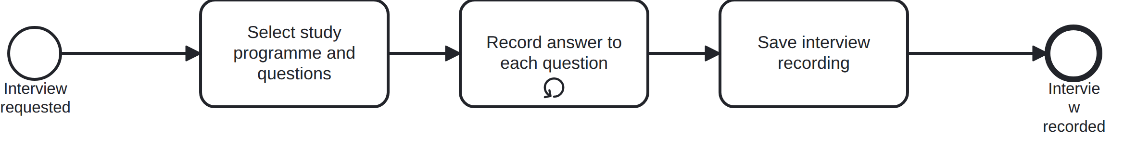
Figure 2.7: Video interview capture stage (BPMN).
The capture stage walks the candidate through the interview. Each question is shown in turn, the answer is recorded from the browser, and the recording is the message that opens the interview branches. In the cohort study the same folder can be filled from a public stand-in video set, so the later agents run without filming anyone.
Every applicant has a dedicated subtree. Scans live under the document-image folder. Optical character recognition writes a text folder and, when a vision model reads the page, a separate model-named folder. Merged page text, per-document summaries, the combined summary, the reconciliation vote, and the eligibility result each have their own folder. The interview side holds the recordings, the extracted audio, the transcripts, the prosody and emotion summary, the grade files, the facial-behaviour files, and the frame descriptions. The folder name is the name of the stage that wrote it. A reviewer who needs one artifact can follow that path. The event log and this tree are the two records of the case: the log says which agent ran, and the tree holds what that agent produced.
Working with the records of real applicants means processing personal and possibly biometric data, which the EU AI Act (European Union, 2024) and the European Commission's white paper (European Commission, 2020) place in the high-risk category. To stay within those limits during development, and to obtain reliable labels for evaluation, the prototype runs entirely on generated data. A generator produces a group of fictitious applicants, each with an academic record, demographic attributes, scanned-looking diploma and transcript images, and a set of interview answers. Because the data is generated, the intended quality of every answer and the true merit of every applicant are known immediately, and those known values become the labels used in Chapter 3. The event-driven path uses the same folders, so a synthetic case and a live recording are read by the same agents.
Recent evidence from an education setting shows that synthetic data can serve privacy and fairness goals at the same time (Q. Liu et al., 2025), which further supports developing and evaluating the prototype on a synthetic cohort rather than on the records of real applicants.

Perceptual Extraction Stages

Document Intelligence
Figure 2.8: Document reading stage (BPMN). Extend the drawing past recognition, through page merge, anonymised summary, and the fork into eligibility and reconciliation.
The document track is a sequence followed by a fork. Each scanned page is cleaned and read. Pages that belong to one document are merged. A summary agent then writes an anonymised account of that document. A parallel gateway splits the summary into two consumers. One reconciles summaries when more than one model has written them. The other checks eligibility against the admission rules. The score waits for eligibility. It does not wait for the reconciliation vote.
Scanned diplomas and transcripts are cleaned with several computer-vision processes (greyscale conversion, adaptive thresholding, morphological cleanup and denoising) and then read with the Tesseract optical character recognition engine (Smith, 2007), which returns both plain text and word-level bounding boxes. Page files that carry a page index in the name are merged into one text file per document. The summary agent has two stages. The first names the document type and the country. The second selects a prompt for that type and country, and falls back to a generic prompt when none matches. The summary drops names and identification numbers. Eligibility reads the combined summary, not the reconciliation file. When models disagree, the vote ignores blank answers, then takes a consensus, otherwise a majority, otherwise the first model in the list. For noisier or cross-border documents, the layout-aware models reviewed in Chapter 1, such as LayoutLM (Xu et al., 2020) and the OCR-free Donut model (Kim et al., 2022), remain the suitable next step. They would replace the reader, not the fork.

Speech Transcription
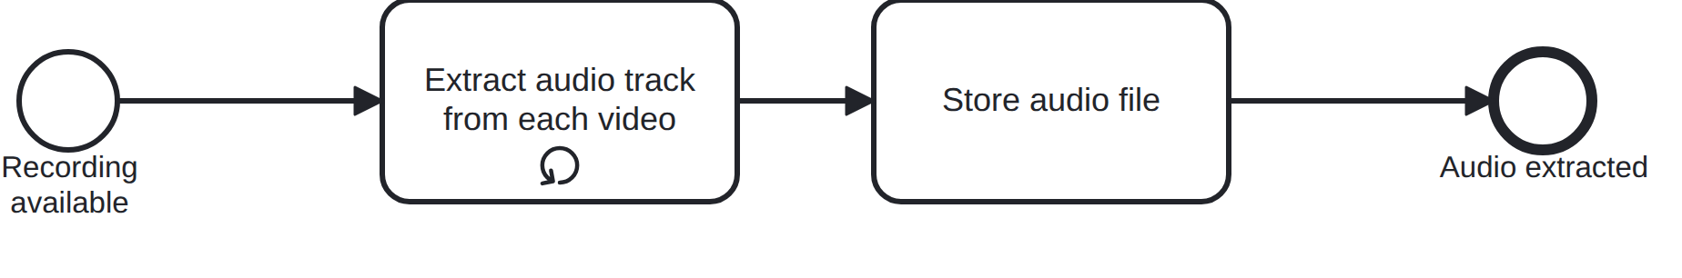
Figure 2.9: Audio extraction stage (BPMN). The outgoing flow is a parallel gateway, not a single arrow to transcription.
The audio agent pulls the spoken track out of each interview video and saves it as a separate audio file. That file is the token for a parallel gateway. Transcription and prosody both consume it, and neither waits for the other.
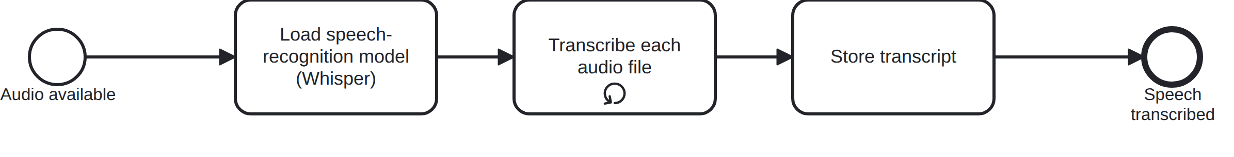
Figure 2.10: Speech transcription stage (BPMN).
Once the speech-recognition model is loaded, this branch runs each audio file through it and writes a plain-text transcript. The grade agent is the next consumer on this branch only. Prosody is not a step after the transcript.
The audio is separated from each video and transcribed with OpenAI's Whisper model (Radford et al., 2022). Whisper was chosen because it holds up well across accents and recording conditions. Because it is trained on a very large weakly supervised corpus, it comes close to human accuracy on varied speech, where transcription quality is normally reported as word error rate. The transcript is an artifact. The grade agent reads that file. It does not call the recogniser.

Prosody
Prosody is the sibling of transcription. The same extracted audio is measured for speaking rate, the share of time spent in pauses, and pitch [CITE: McFee et al., 2015]. The result is written as its own artifact and published as its own completion. The evaluation gateway waits for that completion, so a case is not scored on words alone while the delivery summary is still missing. The present scoring vector does not assign this summary a coefficient. It travels with the case for the reviewer, and a later revision of (2.3) can add it without moving the gateway. A neural speech-emotion model can be run on the same file. It stays unloaded by default, because the interpretable summary is enough for the join and the model download is large.

Visual Context Anchoring and Description
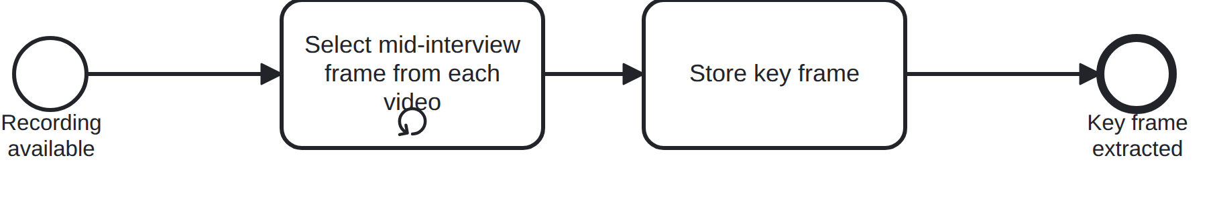
Figure 2.11: Key-frame extraction stage (BPMN). This branch leaves the case fork directly. It does not wait for the transcript.
The key-frame agent takes a single still from the middle of each interview video. That still is the input to the vision-language description. The branch starts when the interview is recorded, in parallel with documents, audio, and face behaviour.
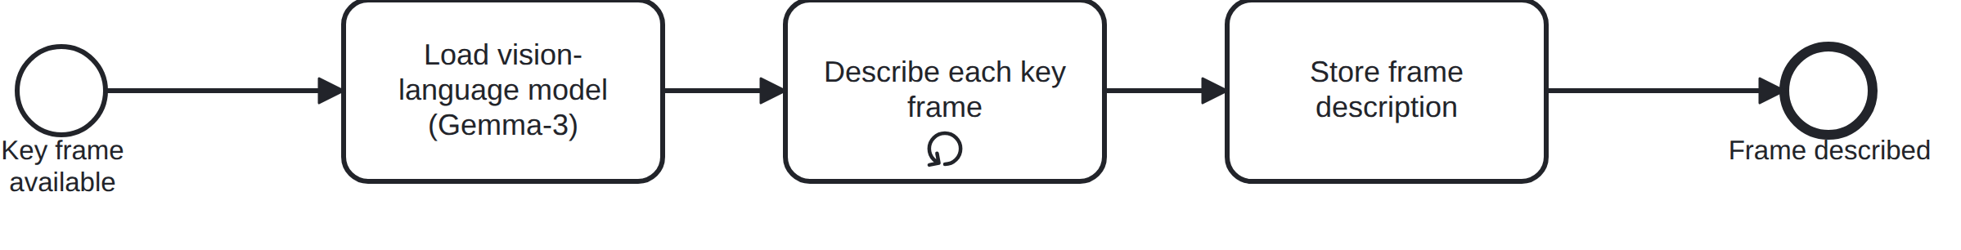
Figure 2.12: Vision-language frame description stage (BPMN).
With the vision-language model loaded, this stage describes each key frame in plain language and stores the text. The completion of this branch is one of the five tokens at the evaluation gateway. A count of distracting settings in the text becomes the visual feature used at scoring.
A stable frame is taken from the midpoint of each interview and described in natural language by a locally hosted Gemma 3 vision-language model [CITE: Gemma Team, 2025]. Writing the description out as text makes an otherwise opaque judgement trackable. Models of this kind, such as CLIP (Radford et al., 2021) and BLIP-2 (J. Li et al., 2023), are capable but tend to hallucinate (H. Liu et al., 2024). Linking each description to a specific, inspectable frame limits that risk, much as the retrospective verification of Wu et al., 2025 does. The privacy split is the other control on this branch: a later or remote model may see the anonymised document summary, and it does not receive the passport scan.
Open vision-language models have moved quickly beyond CLIP and BLIP-2. Instruction-tuned assistants such as LLaVA (H. Liu et al., 2023) answer natural-language questions about an image, newer models like Qwen2-VL (P. Wang et al., 2024) handle images at any resolution while approaching the accuracy of proprietary systems, and a recent survey of these models (Yin et al., 2024) documents abilities such as OCR-free reasoning. This progress is what makes a locally run open model a credible choice for describing the interview frame. The frame agent is swappable for that reason: the next stage reads the text file, whatever model wrote it.

Behavioural Analysis
Figure 2.13: Behavioural analysis stage (BPMN). This branch leaves the case fork in parallel with audio and the frame.
The behaviour agent steps through the video with a facial-landmark model, tracking head pose, gaze, blinking and smiling, then writes a short summary. Its completion is a separate token at the evaluation gateway. It does not wait for the transcript, and the transcript does not wait for it.
A facial-landmark model, built on the MediaPipe perception framework (Lugaresi et al., 2019), runs over the video, and from it the system derives head motion, gaze direction, blink rate and expression metrics, then aggregates them into a structured summary. The scoring vector uses three of those aggregates: a composite behaviour score, a reading-from-notes probability, and a smile rate. These signals help separate spontaneous speech from reading and give a sense of the candidate's delivery, complementing the textual analysis in the way the audio-visual emotion work of (Chennoor et al., 2020) does.

Answer Grading
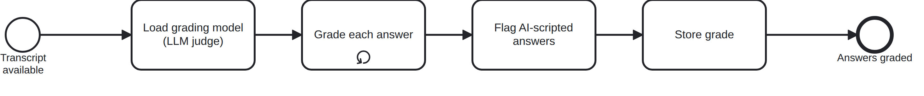
Figure 2.14: Answer grading stage (BPMN). Place this task on the transcription branch, after the transcript and beside prosody.
The grading agent scores each transcript against the question that prompted it. It returns relevance, clarity and structure, and it flags answers that read as if they were lifted from a script. The grade file is one of the five tokens at the evaluation gateway. Prosody joins beside it. Grading does not read the prosody file.
Each transcript is graded against the question that prompted it by a large language model acting as an expert evaluator. Using a strong model as a judge of free-text answers is now an established practice: (Zheng et al., 2023) report that language-model judges agree with human raters at about the same rate as humans agree with each other. The model returns an overall score, sub-scores for relevance, clarity and structure, and a judgement of whether the answer looks natural or read from a generated script. This stage implements the automatic short-answer grading line of work (Bonthu et al., 2024; Lui et al., 2022; Süzen et al., 2020) and adds the script detection that a remote interview now demands. The offline heuristic grader writes the same fields, so the fusion step does not care which grader ran.
Using a large language model as the grader is backed by recent findings that a prompted GPT-4 can match or beat traditional short-answer grading models (Ferreira Mello et al., 2025). The cost of that choice is a dependence on the judge when the heuristic is not the one running, which is why the heuristic remains part of the design rather than a temporary patch.

Multimodal Fusion
The outputs of the perceptual stages have to be combined before they can be scored. The taxonomy of multimodal machine learning set out by (Baltrusaitis et al., 2019), and the more recent fusion review by (Hangloo & Arora, 2025), distinguish early fusion, which merges raw features before modelling, late fusion, which reduces each modality on its own and then combines the summaries, and intermediate fusion in between. The system uses late fusion, and the evaluation gateway is that fusion. The scorer never sees the raw video or the raw scan. The academic record contributes grade-point average, standardised test score, English-proficiency score and years of work experience. The interview contributes the mean answer score, the mean relevance and the rate at which answers were flagged as scripted, three behaviour aggregates, and the share of frame descriptions that mention a distracting setting. Document text does not add an eleventh academic column: the grades it carries are already in the record, while eligibility still has to be present before the gateway fires. Prosody is required at the same gateway and is stored as tempo, pause and pitch, but the present scoring vector does not yet give it a coefficient. These summaries form the vector in (2.3), with the interview means in (2.4).
Let n be the number of answers from one applicant, s_k the overall grade of answer k, and script_k the indicator that answer k was flagged as scripted. The fused vector and the two interview aggregates are
$x = (gpa, test, english, work, ī_overall, ī_rel, r_ai, b_comp, b_read, b_smile, v_dist) ∈ R¹¹$ (2.3)
$ī_overall = (1/n) Σ_k s_k , r_ai = (1/n) Σ_k 1[script_k]$ (2.4)
The remaining interview terms are means over the same answers: relevance, the behaviour composite, the reading-from-notes probability, and the smile rate. The visual term is the fraction of frame descriptions that mention a distracting setting. Academic terms are copied from the record. Each coordinate has a closed range, used both to standardise the letter score and to reject a counterfactual that would leave that range.
(Hangloo & Arora, 2025; Jiao et al., 2024) both note that intermediate fusion is the most expressive option, because it can model interactions between modalities inside a deep network. Late fusion is still the better fit for this prototype. It keeps each modality's contribution visible, which the explanation and fairness stages rely on. It behaves well when data is scarce and heterogeneous. And it lets any one modality be added, dropped or swapped without retraining the rest. Adding a prosody coefficient later is a change to this vector, not a change to the gateway.

Scoring Model
Two logistic scores are specified, and they answer different questions. On the synthetic cohort, the fused vector is mapped to an admission probability by logistic regression on standardised features, as in (2.5). A deliberately simple model was preferred over a higher-capacity one. (Raftopoulos et al., 2024) show that interpretable models such as logistic regression and decision trees predict admission about as well as opaque models while still allowing rule-based, inspectable explanations. (Rudin, 2019) argues more strongly that for high-stakes decisions an inherently interpretable model should be preferred to a black box that is explained after the fact. In a setting where every decision has to be defensible to a reviewer and to the applicant, that argument settles the choice. The letter path does not refit those weights. It uses the fixed linear score in (2.6): each feature is centred on the middle of its allowed range and divided by half the width of that range, the terms are weighted, and a logistic function with a scale of three maps the sum to a probability. The decision threshold is one half in both cases. Coefficients on the letter path are positive where a higher value should help, and negative for the script flag, the reading-from-notes score, and visual distraction.
For the cohort model, μ_j and s_j are the training-set mean and standard deviation of feature j, w and b are the fitted coefficients, and σ is the logistic function. For the letter, c_j is the midpoint of the allowed range of feature j, d_j is half the width of that range, and α_j is the fixed weight.
$z_j = (x_j - μ_j) / s_j , π(x) = σ(wᵀz + b) , ŷ = 1[π(x) ≥ 1/2]$ (2.5)
$l = Σ_j α_j (x_j - c_j) / d_j , π_letter(x) = σ(3l) , ŷ_letter = 1[π_letter(x) ≥ 1/2]$ (2.6)

Explainability
Three explanation methods are applied to the scoring model, each taken from the work reviewed in Chapter 1. They explain the same eleven-feature vector. A fourth constraint, stated in (2.7), limits which of those features a counterfactual is allowed to move.
Shapley Additive Explanations (SHAP), introduced by (Lundberg & Lee, 2017), attribute the score to individual features by treating each feature as a player in a cooperative game and splitting the prediction fairly among them; the method is used for student evaluation by (Johora et al., 2025; Rico-Juan et al., 2025). Across the whole cohort, SHAP gives a global ranking of which features matter most to admission. For one applicant, it shows how each of that applicant's features pushed the decision toward acceptance or rejection. For the logistic model the contribution of a feature is its coefficient times the standardised value, which a reviewer can recompute from (2.5).
Local Interpretable Model-agnostic Explanations (LIME), proposed by (Ribeiro et al., 2016) and applied to student data by (Johora et al., 2025), add a second view by fitting a simple linear model to the scoring model's behaviour around one applicant. Reporting SHAP and LIME for the same applicant lets a reviewer check one explanation against the other.
Counterfactual explanations, following the Diverse Counterfactual Explanations (DiCE) method of (Mothilal et al., 2020) and its use for student evaluation by (Afzaal et al., 2024), answer a more practical question: what is the smallest realistic change to a profile that would flip the decision? The feasible set is (2.7). Academic features stay fixed, inside the bounds already on the record, so the search may suggest a clearer answer, a steadier delivery, or a tidier frame, and it may not suggest a new grade-point average or a new test score. The letter follows the same split. Interview features that sit on the weak side of a fixed target become short advice. A weak academic number is mentioned only as something already on the record, and the flow does not rewrite it. (Wachter et al., 2017) argue that explanations framed as the smallest change needed to obtain a different outcome are well suited to the right-to-explanation provisions of EU data-protection law, which makes them a natural fit for an admissions system that must answer to applicants.
Let A be the index set of academic features, grade-point average, test score, English score and work experience, and let [L_j, H_j] be the allowed range of feature j. A counterfactual x' is feasible only when
$x'_j = x_j for all j ∈ A , and L_j ≤ x'_j ≤ H_j for every j$ (2.7)
Among feasible vectors that cross the decision threshold, the one reported is a smallest change under a plain distance on the interview coordinates. The letter uses a cheaper form of the same constraint: it emits advice only for interview features that lie on the weak side of a fixed target, and it emits a record note, not advice, for a weak academic feature.

Fairness Mitigation and Human Oversight
The system operates in a sensitive domain, so the design treats fairness as part of the pipeline rather than a check bolted on at the end. (Mehrabi et al., 2019) survey how bias creeps into machine-learning systems, and (Chin-Purcell & Chambers, 2021) show it empirically: the trouble is often not an unfair label but a feature that stands in for a protected attribute. The protected attribute is used only to compute these gaps. It is not a column of (2.3). The system measures three group-level metrics. Let SR(a) be the selection rate of group a, the share of that group for whom the decision is admit, as in (2.8). The demographic-parity difference (2.9) is the largest gap in selection rate between groups. The disparate-impact ratio (2.10) is the lowest group selection rate divided by the highest, where the four-fifths rule, formalised for machine learning by (Feldman et al., 2015), reads a value below 0.8 as adverse impact. The equalized-odds difference, in the sense of (Hardt et al., 2016), is the largest gap between groups in true positive rate or false positive rate, that is, the largest gap at which equally deserving applicants are admitted.
$SR(a) = (1/|G_a|) Σ_\{i ∈ G_a\} ŷ_i$ (2.8)
$Δ_DP = max_a SR(a) - min_a SR(a)$ (2.9)
$DI = min_a SR(a) / max_a SR(a) , adverse impact when DI < 4/5$ (2.10)
Two mitigations are available, drawn from the two ends of the fairness-intervention literature. The first is a pre-processing step in the sense of (Kamiran & Calders, 2012). It drops any feature found to act as a biased proxy and retrains, tackling the bias at the source. The second is a post-processing step in the sense of (Hardt et al., 2016). That step leaves the model alone and instead sets a separate decision threshold for each group so that selection rates line up, which helps when the model cannot, or should not, be changed. Both kinds of intervention are standard in open fairness toolkits such as AI Fairness 360 (Bellamy et al., 2018) and Fairlearn (Bird et al., 2020). Either way a human stays in the loop. The fairness report, together with the SHAP, LIME and counterfactual explanations, is the evidence the reviewer weighs before deciding, which is what the EU AI Act and the FAIR-VID framework (Laukaitis et al., 2025) ask for. The progress manager does not take that place. It reports which agents have finished. It does not admit the applicant.
The biases, metrics, mitigations and legal considerations involved here are surveyed for algorithmic hiring by (Fabris et al., 2025), whose account transfers directly to applicant scoring, since the two settings share the same high-stakes and structurally unequal character.

Comparative Analysis of Candidate Technologies
Each stage of the pipeline could have been built from several competing technologies. The choices were not made on raw capability alone. Because the system has to be auditable, fair and compliant with the EU AI Act, the options were weighed against five criteria: task capability; interpretability and auditability; privacy and the ability to run offline on synthetic data; computational cost and ease of setup; and the maturity of the tool. Table 2.1 summarises the decisions, including the three that belong to the event architecture: how agents coordinate, where identifiers are removed, and how prosody is measured. The comparisons that follow give the reasoning for the choices with the most consequential trade-offs.
Table 2.1 Selected Technology for each Pipeline Stage
Stage | Main options considered | Selected | Main reason
Document OCR | Tesseract; LayoutLMv3; Donut | Tesseract | Sufficient on clean synthetic documents; light and offline
Speech transcription | Whisper; wav2vec 2.0; HuBERT | Whisper | Robust across accents with no fine-tuning
Visual description | Local Gemma-3; cloud VLM API; CLIP/BLIP-2 features | Local Gemma-3 | Keeps data on-premises; outputs auditable text
Behaviour analysis | MediaPipe; OpenFace; custom CNN | MediaPipe | Mature, real-time, no training data needed
Answer grading | LLM-as-judge; fine-tuned BERT; lexical distance | LLM-as-judge (+ offline fallback) | Flexible, gives sub-scores and script detection
Fusion | Early; late; intermediate | Late | Keeps each modality interpretable and replaceable
Scoring model | Logistic regression; gradient-boosted trees; deep network | Logistic regression | Interpretable and defensible in a high-stakes setting
Explanation | SHAP; LIME; DiCE | All three | Complementary global, local and actionable views
Fairness mitigation | Pre-processing; in-processing; post-processing | Pre- and post-processing | Addresses the source and the outcome of bias
Coordination | Direct calls; shared folder as the only control; event log | Event log, one consumer per topic | The log orders the work and records it; agents stay replaceable
Document summary | Pass the scan onward; anonymise, then split eligibility from reconciliation | Two-stage anonymised summary, then a fork | Later models do not see names; the audit does not block the score
Prosody | Speech-emotion network; tempo, pauses and pitch | Tempo, pauses and pitch; emotion network optional | The join receives a small interpretable summary
Document OCR. Tesseract (Smith, 2007) was chosen over the layout-aware models (Xu et al., 2020) and Donut (Kim et al., 2022). LayoutLM and Donut are stronger on noisy, irregularly laid-out documents, but they are heavier to run and need GPU resources, and their advantage is small on the clean, well-structured synthetic diplomas and transcripts used here. Tesseract is light, runs offline and returns word-level bounding boxes that keep the output inspectable. The layout-aware models remain the planned upgrade for real, cross-border documents. Whichever reader is used, the summary fork stays: eligibility and reconciliation are consumers of the summary, not steps inside the reader.
Table 2.2 Document Reading Models
Option | Strengths | Weaknesses | Verdict
Tesseract | Light, offline, mature, bounding boxes | Weaker on noisy or complex layouts | Selected for the prototype
LayoutLMv3 | Strong layout-aware extraction | GPU-heavy, more setup | Future upgrade
Donut | OCR-free, end-to-end | GPU-heavy, less interpretable | Future upgrade
Speech transcription. Whisper (Radford et al., 2022) was chosen over wav2vec 2.0 (Baevski et al., 2020) and HuBERT (Hsu et al., 2021). All three are strong, but wav2vec 2.0 and HuBERT generally need fine-tuning on labelled data to reach their best word error rate, whereas Whisper was trained on a very large multilingual corpus and transcribes varied, accented speech well out of the box. For a pipeline that has to handle international applicants without per-language tuning, that robustness is the deciding factor. Prosody is a separate choice on the sibling branch. Tempo, pauses and pitch are taken from a lightweight audio library [CITE: McFee et al., 2015]. A speech-emotion network is available and is left off unless it is requested, because the download is large and the join only needs the small interpretable summary.
Visual description. A locally hosted Gemma 3 vision-language model [CITE: Gemma Team, 2025] was chosen over both a cloud vision API and a features-only model such as CLIP (Radford et al., 2021) or BLIP-2 (J. Li et al., 2023). A cloud API would be the most capable option but would send applicant imagery to a third party, which is hard to reconcile with the EU AI Act and the General Data Protection Regulation [CITE: European Union, 2016]. CLIP and BLIP-2 yield embeddings rather than the readable descriptions the audit trail needs. Running an open-weight model locally keeps the data on the premises and produces text a reviewer can read, at the cost of some capability and local compute. The same privacy rule covers documents: identifiers are removed in the summary, before any later model runs.
Answer grading. A language model acting as a judge (Zheng et al., 2023) was chosen over a fine-tuned short-answer grader such as the DistilBERT model of (Bonthu et al., 2024) and over purely lexical methods such as the Bag-of-Words and Hamming distance approach of (Süzen et al., 2020). The lexical methods are transparent but cannot judge open-ended interview answers or notice a scripted answer. A fine-tuned grader would need a labelled training set the project does not have. A language-model judge needs no training, returns the relevance, clarity and structure sub-scores the fusion stage uses, and can flag scripted answers. Its cost is the dependence on an external service and the noise inherent in model judgements, which is why an offline heuristic grader was also built as a fallback (see Chapter 3). Both graders publish the same kind of grade message, so the evaluation gateway is unchanged.
Fusion strategy. Late fusion was chosen over early and intermediate fusion. The reasoning is given in the multimodal fusion section and follows the taxonomy of (Baltrusaitis et al., 2019). Table 2.3 sets out the trade-off directly. The event design makes the same choice concrete: the converging gateway fires on summaries, and no agent forwards a raw scan or a raw video into the scorer.
Table 2.3 Fusion Strategies
Strategy | Strengths | Weaknesses | Verdict
Early | Captures low-level cross-modal links | Needs aligned raw features; opaque | Rejected
Late | Interpretable, robust, modular | Misses fine cross-modal interactions | Selected
Intermediate | Most expressive | Needs a deep model and more data | Future work
Scoring model. Logistic regression was chosen over gradient-boosted trees or a deep network. The explanation and fairness stages only work if a decision can be traced back to the features that drove it, and (Rudin, 2019) argues that high-stakes decisions should rely on a model that is interpretable by design rather than a black box explained after the fact. With eleven features, a heavier model would add little accuracy and would make the system harder to audit. The letter score is in the same family. It is a logistic function of a linear form, with coefficients fixed in advance rather than fitted on the case being decided.
Table 2.4 Scoring Models
Option | Strengths | Weaknesses | Verdict
Logistic regression | Interpretable, calibrated, light | Linear decision surface | Selected
Gradient-boosted trees | Higher accuracy on tabular data | Harder to audit; needs more data | Rejected for now
Deep network | Highest capacity | Opaque, data-hungry | Rejected
Fairness mitigation. Rather than pick a single technique, the system combines a pre-processing intervention (Kamiran & Calders, 2012) that removes a biased proxy feature with a post-processing intervention (Hardt et al., 2016) that calibrates per-group thresholds. In-processing methods, which build a fairness penalty into training, were not used: they are tied to the model and would compromise the interpretability that motivated the choice of logistic regression. The two chosen interventions attack the problem at different points, the source and the outcome, and both are available in the standard toolkits AI Fairness 360 (Bellamy et al., 2018) and Fairlearn (Bird et al., 2020). Coordination of the agents is a separate decision, recorded below. Direct calls were rejected because a call graph hides the order of beliefs. A shared folder alone was rejected as the control mechanism because a new file does not say which consumer must run next. The event log does both: it orders the work and leaves a record [CITE: Kreps, Narkhede and Rao, 2011].
Table 2.5 Fairness Mitigation Models
Strategy | Example | Strengths | Weaknesses | Verdict
Pre-processing | Remove biased proxy (Kamiran & Calders, 2012) | Model-agnostic; fixes the source | May lower accuracy | Selected
In-processing | Fairness penalty during training | Strong control | Tied to model; less interpretable | Rejected
Post-processing | Per-group thresholds (Hardt et al., 2016) | No retraining; precise on the outcome | Needs group labels at decision time | Selected

Architectural Decision Record
This section records the principal architectural decisions behind the system. Each entry follows the usual decision-record form: a short statement of the decision, its status, the context that prompted it, the alternatives that were weighed, and the consequences that follow. ADR-1 is restated for the event log. ADR-9 to ADR-12 are the decisions that distinguish the present design from the earlier file-only pipeline: reconciliation does not gate the score, identifiers stop at the summary, counterfactual advice cannot rewrite the academic record, and the progress manager does not score.
Table 2.6 Architectural Decision Record Table
ID | Decision | Status | Context | Detail | Consequences
ADR 1 | Events for control, files for evidence | Accepted. | A high-risk admissions system must be auditable, and agents run as separate programs, some of them optional. | Each agent reads one topic and publishes the next, and writes its own artifact without overwriting another stage. The progress manager reads a side channel. A single-process fallback runs the same handlers when no broker is configured. | (+) The log is a control audit and the file tree is an evidence audit; agents are loosely coupled and can be replaced. (−) Requires a log, or the single-process fallback, and stores each artifact separately.
ADR 2 | Synthetic data for development and evaluation | Accepted. | Real applicant records are personal and partly biometric data, which the EU AI Act places in the high-risk category. | Develop and evaluate the prototype on a generated, labelled synthetic cohort instead of real data. | (+) Avoids processing personal data; supplies ground-truth labels; allows controlled fairness experiments. (−) Limits external validity until the system is tested on real data under proper safeguards.
ADR 3 | Late fusion of per-modality summaries | Accepted. | The perceptual stages produce heterogeneous outputs that must be combined for scoring, and the result has to stay interpretable. | Reduce each modality to an interpretable summary and concatenate the summaries into one feature vector (late fusion). | (+) Each modality's contribution stays visible to the explanation and fairness stages; modalities can be added or swapped freely. (−) Misses fine-grained cross-modal interactions; intermediate fusion is deferred to future work.
ADR 4 | Interpretable logistic-regression scorer | Accepted. | Every admission decision must be defensible to a reviewer and to the applicant (Rudin, 2019) | Use logistic regression on standardised features as the scoring model. | (+) Calibrated, transparent decisions that SHAP, LIME and counterfactuals can explain cleanly. (−) A linear decision surface that may underfit if the feature set grows much richer.
ADR 5 | Language-model grading with an offline heuristic fallback | Accepted. | Open-ended interview answers must be graded and checked for AI-written scripts, with no labelled training set available, and experiments must be reproducible without an external service. | Grade with a language model acting as a judge (Zheng et al., 2023) in production and provide a heuristic grader with the same output format for offline runs. | (+) Rich sub-scores and script detection with no training; offline reproducibility. (−) Production grading depends on an external service and inherits model-judgement noise; the heuristic fallback is rougher.
ADR 6 | Local open-weight vision-language model | Accepted. | The visual-description stage processes applicant imagery, which should not leave the premises. | Run an open-weight Gemma-3 model locally rather than call a cloud vision API. | (+) Keeps data on-premises and yields readable, auditable descriptions. (−) Lower capability than a frontier cloud model and a local GPU requirement.
ADR 7 | Layered fairness mitigation | Accepted. | Bias can enter through a proxy feature even when the label is fair (Mehrabi et al., 2019) | Combine a pre-processing step that removes the biased proxy (Kamiran & Calders, 2012) with a post-processing step that sets per-group thresholds (Hardt et al., 2016); do not use in-processing methods. | (+) Tackles both the source and the outcome of bias while preserving model interpretability. (−) The threshold step needs the protected attribute at decision time, which must itself be governed carefully.
ADR 8 | Tesseract for the document track | Accepted (provisional). | The prototype must read clean synthetic documents offline and cheaply. | Use Tesseract OCR (Smith, 2007) rather than a layout-aware model. | (+) Light, offline, mature, with inspectable bounding boxes. (−) Weaker on noisy real-world layouts; LayoutLMv3 or Donut is the planned upgrade.
ADR 9 | Reconciliation does not gate the score | Accepted. | Eligibility and the reconciliation vote both read the anonymised summary, but they answer different questions. Waiting for the vote would hold up a decision on an audit. | The evaluation gateway is J_eval in (2.1). Eligibility is a member. Reconciliation is not. The closing gateway J_close in (2.2) does include the vote, so the case is not marked complete until the audit has finished. | (+) The decision matches the notebook rule that eligibility reads the summary, not the vote. (−) A reviewer who opens the case at the moment of scoring may not yet have the reconciliation file.
ADR 10 | Privacy split at the summary step | Accepted. | Later models, including a model reached over a network, must not receive the passport scan or the applicant's name and identification number. | The summary agent drops names and identification numbers. Eligibility, reconciliation, and any later model read that summary. The frame agent sees the interview frame, not the scan. | (+) Identity is removed before the stages most likely to leave the machine. (−) A summary can still leak identity if the prompt fails, so the summary text stays something a reviewer can read.
ADR 11 | Interview-only counterfactual advice | Accepted. | A suggested change that invents a new grade-point average or a new test score is not advice the applicant can act on inside this process, and it is not something the system should write back onto the record. | Counterfactuals are restricted to (2.7). The letter names weak interview features as improvements and names weak academic features only as already on the record. | (+) The advice is actionable and the record is stable. (−) An applicant whose only weakness is academic receives no interview advice that would flip the decision.
ADR 12 | Progress manager separated from scoring | Accepted. | Staff need a single place to ask how far a case has got. That place must not become a second scorer. | The manager reads the progress topic and the case file. It answers over HTTP and over a request topic. It marks the case complete only under J_close. The evaluation agent remains the only publisher of the score. | (+) Status and the decision have different owners, so a status query cannot change an outcome. (−) The manager's case file can lag the log by one message.

INITIAL EXPERIMENTAL STUDY
This chapter reports an initial experimental study of the prototype from Chapter 2, run on a controlled generated cohort.
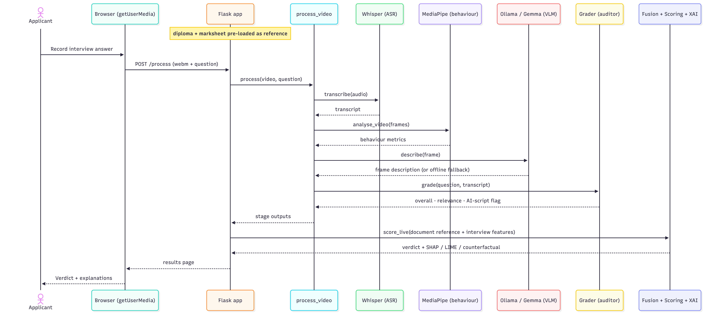
Figure 3.1: Sequence Diagram of runtime interaction in the live web application.
The runtime sequence shows what happens, step by step, when a candidate records an answer in the web application. The browser captures the video and sends it to the server, which transcribes the speech, analyses behaviour, describes the frame and grades the answer, fuses these with the candidate's already-loaded documents, and returns the verdict together with its explanations.

Implementation of the System
The prototype is implemented in Python 3.12.3 as a small package split into four parts. A web application built with Flask (Ronacher, 2010) serves the recording interface and the results page. A processing module takes one recorded interview and runs it through the perception stages in turn. A separate pipeline package holds the decision logic, namely the fusion, scoring, explanation and fairness stages. A data-generation package produces the synthetic cohort, and a small set of experiment scripts runs the study from end to end. Every stage reads from and writes to the shared artifact tree described in Chapter 2, so each intermediate result is kept on disk as its own file.
Each stage is built on an established, openly available tool. The audio track is extracted with FFmpeg (FFMpeg Developers, 2016) and a still frame with OpenCV (Bradski, 2000), the speech is transcribed by a local Whisper model, the key frame is described by a Gemma-3 (Gemma Team et al., 2025) vision-language model served through Ollama (Ollama Team, 2025) with a text fallback when the model is not running, non-verbal behaviour is measured with MediaPipe, and the transcript is graded either by a language model acting as a judge or, for reproducible offline runs, by a heuristic grader that returns the same fields. The fused feature vector is scored by a scikit-learn (Pedregosa et al., 2018) logistic-regression model, explained with SHAP, LIME and DiCE, and checked for fairness with the metrics and mitigations from the Fairlearn and AI Fairness 360 toolkits.
The system runs in two modes. In the live demonstration a candidate records an answer in the browser and the server returns the transcript, the frame description, the behaviour metrics and the grade for that single interview. For the experimental study the same stages are driven over a whole generated cohort by the experiment scripts, which produce the scoring, explanation and fairness results reported in this chapter. The heavier stages such as transcription and frame description were run on a GPU while the lighter stages run on a CPU, and the study below uses the offline grader so that it can be reproduced without an external service.

Experimental Setup
The cohort had 80 applicants spread across four master's programmes, each answering four programme-specific interview questions. Every applicant was given an academic record (grade-point average, standardised test score, English-proficiency score and work experience), demographic attributes (gender, region and age), two scanned-looking document images, and four interview answers. Each answer was written to fit one of four quality tiers (strong, weak, off-topic or AI-scripted), and that tier is its ground-truth label.
The merit of each applicant, and so the reference admission decision, was computed from academic ability alone and does not depend on any demographic attribute, so the correct label is fair by design. To study fairness, a disparity was still injected into the data: the measured test score of one region group was lowered by twelve points, imitating unequal access to test preparation without touching true merit. The scoring model was trained on 65% of the cohort and tested on the remaining 35%, stratified on the admission label. The offline heuristic grader from Chapter 2 stood in for the language-model grader so the study could be reproduced without an external service.

Interview Grading (Sanity Check)
The grading stage recovered the intended quality tier for every answer and flagged all the AI-scripted answers. These numbers confirm that the grading and fusion stages are wired up correctly and that the script detector reacts to the planted markers. They should be read only as a sanity check, though. The synthetic answers come from tier-specific templates, which makes them far easier to separate than real ones, so the production figures will have to come from swapping in the language-model grader and testing on more natural responses.
This caution matches recent work comparing language-model grades with teacher ratings, which finds broad agreement across several writing dimensions but still recommends human oversight (Seßler et al., 2025).

Scoring Conformance
Table 3.1 reports how often the model's admission decisions matched the reference decisions on the held-out test set.
Table 3.1 Scoring conformance on the held-out test set.
Metric | Value
Accuracy | 0.857
F1-score | 0.818
ROC-AUC | 0.913
The model matched the reference decision 85.7% of the time, with an area under the ROC curve of 0.91. This is early evidence that the pipeline can approximate a consistent reference decision, and it lines up with the headline figure in the Introduction.
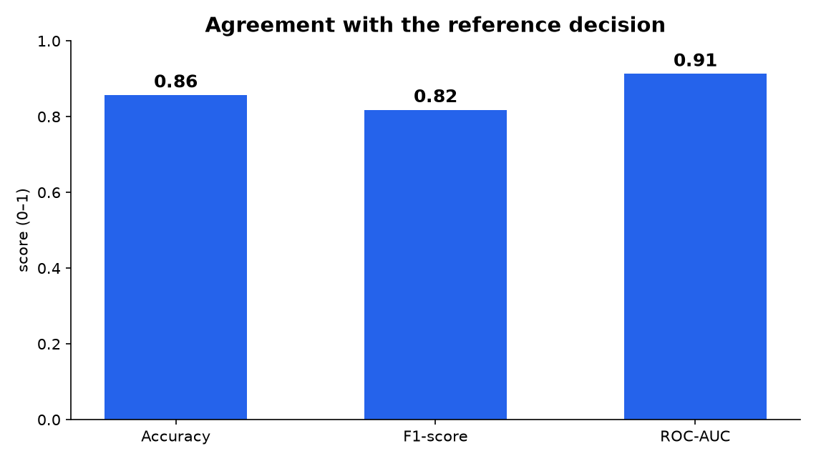
Figure 3.2: Agreement with the reference decision (accuracy, F1 and ROC-AUC).
The bars give the three headline scores on the held-out test set. Accuracy is how often the model's decision matches the reference decision, the F1 score balances admitting the right candidates against wrongly admitting others, and the ROC-AUC measures how confidently the model separates strong profiles from weak ones, where 0.5 would be a random coin-toss guessing and 1.0 would be perfect. All three sit high for an early prototype, with the ROC-AUC at 0.91.

Explainability Results
The global SHAP analysis put grade-point average well ahead of the other features, followed by the standardised test score, work experience, English-proficiency score and, last, the interview-derived features. That ordering matches how the reference label was built, which suggests the model learned a sensible notion of merit.
A worked example makes the local explanations concrete. Take a rejected applicant from the test set. The local SHAP attribution showed that a below-average grade-point average and test score were the two largest negative contributions to the decision. The counterfactual analysis suggested by DICE (Afzaal et al., 2024), found that raising the grade-point average by about 0.7 points and the test score by about 8 points would have increased the admission probability from 0.03 to just over the 0.50 threshold. Between them, the two explanations show how the system can justify a rejection and, at the same time, tell the applicant what to work on.

Fairness Analysis
Table 3.2 shows the fairness metrics against the protected attribute, for the baseline model and after each mitigation.
Table 3.2 Fairness metrics before and after mitigation.
Configuration | Disparate-impact ratio | Demographic-parity difference | Four-fifths rule
Baseline model | 0.475 | 0.289 | Fail
Mitigation: remove biased proxy | 0.666 | 0.167 | Fail
Mitigation: per-group thresholds | 0.918 | 0.039 | Pass
A protected attribute is a characteristic that a decision is not allowed to be based on, e.g. gender, race or age. The fairness metrics all compare how the model treats the groups of a protected attribute. The selection rate is the share of a group that the model admits. The demographic-parity difference is the gap between the highest and lowest group selection rates, so a value near zero means every group is admitted at a similar rate. The disparate-impact ratio divides the lowest group's selection rate by the highest: 1.0 is perfect parity, and the four-fifths rule treats anything below 0.8 as a sign of adverse impact.
The baseline model returned a disparate-impact ratio of 0.48, far below the 0.8 mark of the four-fifths rule, which points to a real adverse impact on the disadvantaged group even though the underlying label was fair. Removing the biased proxy feature raised the ratio to 0.67, which confirms the feature carried a good part of the bias, though not all of it. Setting a separate decision threshold per group raised the ratio to 0.92 and cut the demographic-parity difference to 0.04, clearing the four-fifths rule.
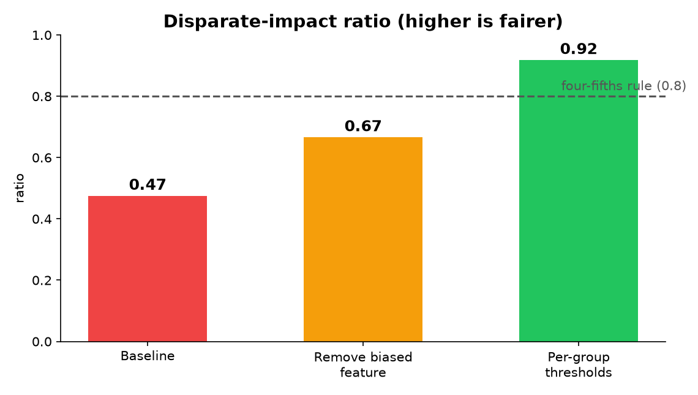
Figure 3.3: Disparate-impact ratio before and after mitigation.
The bars track the disparate-impact ratio, the admission rate of the worst-off group divided by that of the best-off group, where 1.0 is parity and the dashed line at 0.8 marks the four-fifths rule. With the injected bias the baseline fails at 0.47. Dropping the proxy feature lifts it to 0.67, still short of the line, and setting a separate decision threshold per group brings it to 0.92, clear of the rule. The pipeline does not only flag the unfairness, but it also brings the decision back into compliance.
To check that the disparity came from the injected gap and not from some anomaly of the model, the cohort was regenerated with the gap removed. In that control run the baseline ratio rose from 0.48 to 0.67, which confirms the gap was a genuine cause of the unfairness. The disparity left over in the control run is down to sampling variation in a small cohort.
Measuring fairness on features extracted from video is itself an active question: a case study of automated video interviews sets out how bias should be assessed when such behavioural features feed a candidate's score (Booth et al., 2023).

Discussion and Threats to Validity
These results are an initial feasibility study, not a final evaluation. The main limitation is the synthetic data and the heuristic grader, which together inflate the grading figures and, to a smaller degree, the scoring figures, and which limit how far the findings generalise. The cohort is also small, so the fairness metrics move with the sample, as the control run showed. Finally, the prototype uses late fusion, which is simpler than the intermediate fusion the literature prefers (Hangloo & Arora, 2025; Jiao et al., 2024) because keeping each modality separate makes the explanation and fairness checks possible, and additionally because intermediate fusion would overfit on a small cohort. Each of these points maps into an item of future work.

CONCLUSION
This section presents one conclusion for each of the three tasks set out in the Introduction:
- For the first task: the conducted analysis of literature pertaining to applicant profile evaluation shows that recent research strongly favours multimodal, transformer-based architectures capable of integrating information of all types to handle complex evaluation tasks. Studies collectively show that merging different modalities of data contributes to more accurate evaluations than unimodal methods. It can also be concluded that human supervision and the inclusion of fairness-aware designs that eliminate racial, ethnic or gender-based biases are extremely important in high-stakes domains like education and university admissions to maintain fairness in admissions.
- For the second task: the proposed design combines computer vision, speech processing and natural language processing through multimodal fusion. The fused evidence then passes through an interpretable scoring model, a set of explanation methods and a fairness-mitigation stage, forming a single pipeline that can be audited. Throughout, a human reviewer stays in the loop, and the system turns the extracted evidence into a justified, fairness-checked admission score.
- For the third task: A prototype of this pipeline was implemented and evaluated in an initial experimental study on a fully synthetic, labelled cohort, so as to respect the data-protection requirements that apply to the records of real applicants. The scoring model reproduced the reference admission decision with an accuracy of about 86% and an area under the ROC curve of 0.91, the explanation stage produced coherent global and instance-level attributions together with actionable counterfactuals, and the fairness stage detected a deliberately injected demographic disparity and reduced it from a failing disparate-impact ratio back into compliance with the four-fifths rule. Taken together, these results provide initial evidence that an interpretable and fairness-aware multimodal model is a feasible and transparent basis for automated admission decisions, and that auditability, human oversight and fairness can be treated as core design properties rather than as additions made after the fact.

Further Works
Future works will concentrate on large-scale deployment of the implemented model and evaluation using real-world admission data to assess generalization, accuracy and fairness during applicant evaluation. Technical improvements may include adaptive multimodal fusion that dynamically adjusts each source’s importance to the context, estimation of uncertainty across different modalities, and tighter integration of explainable AI methods for decision auditing. In addition, continuous bias detection, monitoring and supervision methodologies should be developed to ensure compliance with regulatory and ethical requirements. A continuous activity will also be to optimize system latency and scalability, since it is essential for practical use in high-volume applicant screening scenarios.
The planned work begins by completing and strengthening the prototype. The lightweight grader used in the initial study will be replaced by the large-language-model grader and re-evaluated on human interview responses rather than template-generated answers, the synthetic cohort will be enlarged so that the accuracy and, in particular, the fairness measurements become statistically stable, and the document-reading stage will be upgraded from optical character recognition to layout-aware models for robustness on noisier and cross-border documents. The interview track will also be extended from audio and transcripts towards generated talking-head video, so that the visual and behavioural stages can be exercised from end to end.
The work will then move from synthetic data towards evaluation on real admission data under appropriate ethical and legal safeguards, in order to measure how well the accuracy and fairness of the system generalise beyond a controlled setting. The final phase will consolidate the perception, fusion, scoring, explanation and fairness components into a single integrated system supervised by a human, extend the fairness work with continuous monitoring so that compliance is maintained over time, and present a complete evaluation of the system together with a discussion of its limitations.

REFERENCES
Afzaal, M., Zia, A., Nouri, J., & Fors, U. (2024). Informative Feedback and Explainable AI-Based Recommendations to Support Students’ Self-regulation. Technology, Knowledge and Learning, 29(1), 331–354. https://doi.org/10.1007/s10758-023-09650-0
Alayrac, J.-B., Donahue, J., Luc, P., Miech, A., Barr, I., Hasson, Y., Lenc, K., Mensch, A., Millican, K., Reynolds, M., Ring, R., Rutherford, E., Cabi, S., Han, T., Gong, Z., Samangooei, S., Monteiro, M., Menick, J., Borgeaud, S., … Simonyan, K. (2022). Flamingo: a Visual Language Model for Few-Shot Learning. https://doi.org/10.48550/arXiv.2204.14198
Anthropic PBC. (2025, November 24). Introducing Claude Opus 4.5. https://www.anthropic.com/news/claude-opus-4-5
Appalaraju, S., Jasani, B., Kota, B. U., Xie, Y., & Manmatha, R. (2021). DocFormer: End-to-End Transformer for Document Understanding. https://doi.org/10.48550/arXiv.2106.11539
Babaee, A., & Shank, D. B. (2025). Trust and procedural justice mediate the effects of AI hiring on organizational attraction and intent to apply. Discover Artificial Intelligence, 5(1), 375. https://doi.org/10.1007/s44163-025-00633-x
Baevski, A., Zhou, H., Mohamed, A., & Auli, M. (2020). wav2vec 2.0: A Framework for Self-Supervised Learning of Speech Representations. https://doi.org/10.48550/arXiv.2006.11477
Baltrusaitis, T., Ahuja, C., & Morency, L.-P. (2019). Multimodal Machine Learning: A Survey and Taxonomy. IEEE Transactions on Pattern Analysis and Machine Intelligence, 41(2), 423–443. https://doi.org/10.1109/TPAMI.2018.2798607
Bellamy, R. K. E., Dey, K., Hind, M., Hoffman, S. C., Houde, S., Kannan, K., Lohia, P., Martino, J., Mehta, S., Mojsilovic, A., Nagar, S., Ramamurthy, K. N., Richards, J., Saha, D., Sattigeri, P., Singh, M., Varshney, K. R., & Zhang, Y. (2018). AI Fairness 360: An Extensible Toolkit for Detecting, Understanding, and Mitigating Unwanted Algorithmic Bias.
Berhanu, F., & Abera, A. (2015). Students’ Performance Prediction based on their Academic Record. International Journal of Computer Applications, 131(5), 27–35. https://doi.org/10.5120/ijca2015907348
Bird, S., Dudík, M., Edgar, R., Horn, B., Lutz, R., Milan, V., Sameki, M., Wallach, H., & Walker, K. (2020). Fairlearn: A toolkit for assessing and improving fairness in AI (Number MSR-TR-2020-32). https://www.microsoft.com/en-us/research/publication/fairlearn-a-toolkit-for-assessing-and-improving-fairness-in-ai/
Bonthu, S., Sree, S. R., & Krishna Prasad, M. H. M. (2024). Framework for automation of short answer grading based on domain-specific pre-training. Engineering Applications of Artificial Intelligence, 137, 109163. https://doi.org/10.1016/j.engappai.2024.109163
Bonthu, S., Sree, S. R., & Prasad, M. H. M. K. (2025). SPRAG: building and benchmarking a Short Programming-Related Answer Grading dataset. International Journal of Data Science and Analytics, 20(3), 1871–1883. https://doi.org/10.1007/s41060-024-00576-z
Booth, B. M., Hickman, L., Subburaj, S. K., Tay, L., Woo, S. E., & DMello, S. K. (2023). Integrating Psychometrics and Computing Perspectives on Bias and Fairness in Affective Computing: A Case Study of Automated Video Interviews. https://doi.org/10.1109/MSP.2021.3106615
Bradski, G. (2000). The OpenCV Library. Dr. Dobb’s Journal of Software Tools.
Camunda Services GmbH. (2024). Camunda Modeler. https://camunda.com/
Chen, Z. (2023). Collaboration among recruiters and artificial intelligence: removing human prejudices in employment. Cognition, Technology & Work, 25(1), 135–149. https://doi.org/10.1007/s10111-022-00716-0
Chennoor, S. N., Madhur, B. R. K., Ali, M., & Kumar, T. K. (2020). Human Emotion Detection from Audio and Video Signals. https://doi.org/10.48550/arXiv.2006.11871
Chiang, S., Brennan, T., Dogan, F. I., Cheong, J., & Gunes, H. (2026). FAIR_XAI: Improving Multimodal Foundation Model Fairness via Explainability for Wellbeing Assessment.
Chin-Purcell, L., & Chambers, A. (2021). Investigating accuracy disparities for gender classification using convolutional neural networks. 2021 IEEE International Symposium on Technology and Society (ISTAS), 1–7. https://doi.org/10.1109/ISTAS52410.2021.9629153
Chu, Y., Li, H., Yang, K., Copur-Gencturk, Y., Haudek, K., Krajcik, J., & Tang, J. (2026). Optimizing In-Context Demonstrations for LLM-based Automated Grading.
Comanici, G., Bieber, E., Schaekermann, M., Pasupat, I., Sachdeva, N., Dhillon, I., Blistein, M., Ram, O., Zhang, D., Rosen, E., Marris, L., Petulla, S., Gaffney, C., Aharoni, A., Lintz, N., Pais, T. C., Jacobsson, H., Szpektor, I., Jiang, N.-J., … Helmholz, W. (2025). Gemini 2.5: Pushing the Frontier with Advanced Reasoning, Multimodality, Long Context, and Next Generation Agentic Capabilities. https://doi.org/10.48550/arXiv.2507.06261
Cong, L., Hahn, S., Gombert, S., Camus, L., Drachsler, H., & Kroehne, U. (2026). Estimating LLM Grading Ability and Response Difficulty in Automatic Short Answer Grading via Item Response Theory.
Curtis, A., & Kidd, C. (2024, October 15). What Is Multimodal AI? A Complete Introduction . Splunk Blogs. https://www.splunk.com/en_us/blog/learn/multimodal-ai.html
Deng, J., Dong, W., Socher, R., Li, L.-J., Kai Li, & Li Fei-Fei. (2009). ImageNet: A large-scale hierarchical image database. 2009 IEEE Conference on Computer Vision and Pattern Recognition, 248–255. https://doi.org/10.1109/CVPR.2009.5206848
Desplanques, B., Thienpondt, J., & Demuynck, K. (2020). ECAPA-TDNN: Emphasized Channel Attention, Propagation and Aggregation in TDNN Based Speaker Verification. https://doi.org/10.21437/Interspeech.2020-2650
Dunlop, P. D., Hickman, L., Holtrop, D., & Powell, D. M. (2025). Asynchronous Video Interviews in Recruitment and Selection: Lights, Camera, Action! International Journal of Selection and Assessment, 33(2). https://doi.org/10.1111/ijsa.70010
Emirtekin, E. (2025). Large Language Model-Powered Automated Assessment: A Systematic Review. Applied Sciences, 15(10), 5683. https://doi.org/10.3390/app15105683
Erturk, S., van Tilburg, W. A. P., & Igou, E. R. (2022). Off the mark: Repetitive marking undermines essay evaluations due to boredom. Motivation and Emotion, 46(2), 264–275. https://doi.org/10.1007/s11031-022-09929-2
European Commission. (2020). WHITE PAPER On Artificial Intelligence—A European approach to excellence and trust. https://eur-lex.europa.eu/legal-content/EN/ALL/?uri=CELEX:52020DC0065
Eyben, F., Wöllmer, M., & Schuller, B. (2010). Opensmile. Proceedings of the 18th ACM International Conference on Multimedia, 1459–1462. https://doi.org/10.1145/1873951.1874246
Fabris, A., Baranowska, N., Dennis, M. J., Graus, D., Hacker, P., Saldivar, J., Borgesius, F. Z., & Biega, A. J. (2025). Fairness and Bias in Algorithmic Hiring: a Multidisciplinary Survey. https://doi.org/10.1145/3696457
Fahmi, A., & Kahraman, C. (2017). Fuzzy Evaluation of Examinees Through Multiple Choice Questions. Informatica, 28(4), 609–628. https://doi.org/10.15388/Informatica.2017.148
Falls, B., Willis, C., & Liff, J. (2025). The Impact of Explanations on Applicant Reactions to Automated Asynchronous Video Interviews. International Journal of Selection and Assessment, 33(2). https://doi.org/10.1111/ijsa.70009
Fan, Y., Kang, J., Li, L., Li, K., Chen, H., Cheng, S., Zhang, P., Zhou, Z., Cai, Y., & Wang, D. (2019). CN-CELEB: a challenging Chinese speaker recognition dataset. https://doi.org/10.48550/arXiv.1911.01799
Feldman, M., Friedler, S. A., Moeller, J., Scheidegger, C., & Venkatasubramanian, S. (2015). Certifying and Removing Disparate Impact. Proceedings of the 21th ACM SIGKDD International Conference on Knowledge Discovery and Data Mining, 259–268. https://doi.org/10.1145/2783258.2783311
Ferreira Mello, R., Pereira Junior, C., Rodrigues, L., Pereira, F. D., Cabral, L., Costa, N., Ramalho, G., & Gasevic, D. (2025). Automatic Short Answer Grading in the LLM Era: Does GPT-4 with Prompt Engineering beat Traditional Models? Proceedings of the 15th International Learning Analytics and Knowledge Conference, 93–103. https://doi.org/10.1145/3706468.3706481
Ferrer, R., Turgut, D., Chen, Z., & Sonkar, S. (2026). When Can We Trust LLM Graders? Calibrating Confidence for Automated Assessment.
FFMpeg Developers. (2016). ffmpeg tool. http://ffmpeg.org/
Gaggioli, A., Casaburi, G., Ercolani, L., Collova’, F., Torre, P., & Davide, F. (2025). Assessing the Reliability and Validity of Large Language Models for Automated Assessment of Student Essays in Higher Education.
Gemma Team, Kamath, A., Ferret, J., Pathak, S., Vieillard, N., Merhej, R., Perrin, S., Matejovicova, T., Ramé, A., Rivière, M., Rouillard, L., Mesnard, T., Cideron, G., Grill, J., Ramos, S., Yvinec, E., Casbon, M., Pot, E., Penchev, I., … Hussenot, L. (2025). Gemma 3 Technical Report.
Graliński, F., Stanisławek, T., Wróblewska, A., Lipiński, D., Kaliska, A., Rosalska, P., Topolski, B., & Biecek, P. (2020). Kleister: A novel task for Information Extraction involving Long Documents with Complex Layout. https://doi.org/10.48550/arXiv.2003.02356
Guevara-Reyes, R., Ortiz-Garcés, I., Andrade, R., Cox-Riquetti, F., & Villegas-Ch, W. (2025). Machine learning models for academic performance prediction: interpretability and application in educational decision-making. Frontiers in Education, 10. https://doi.org/10.3389/feduc.2025.1632315
Haliassos, A., Vougioukas, K., Petridis, S., & Pantic, M. (2021). Lips Don’t Lie: A Generalisable and Robust Approach to Face Forgery Detection. https://doi.org/10.48550/arXiv.2012.07657
Hamming, R. W. (1950). Error Detecting and Error Correcting Codes. Bell System Technical Journal, 29(2), 147–160. https://doi.org/10.1002/j.1538-7305.1950.tb00463.x
Hangloo, S., & Arora, B. (2025). Multimodal fusion techniques: Review, data representation, information fusion, and application areas. Neurocomputing, 649, 130827. https://doi.org/10.1016/j.neucom.2025.130827
Harada, K., Yoshida, L., Kojima, T., Iwasawa, Y., & Matsuo, Y. (2025). Automated Refinement of Essay Scoring Rubrics for Language Models via Reflect-and-Revise.
Hardt, M., Price, E., & Srebro, N. (2016). Equality of Opportunity in Supervised Learning.
Harley, A. W., Ufkes, A., & Derpanis, K. G. (2015). Evaluation of Deep Convolutional Nets for Document Image Classification and Retrieval. https://doi.org/10.48550/arXiv.1502.07058
Heilala, V., Araya, R., & Hämäläinen, R. (2025). Beyond Text-to-Text: An Overview of Multimodal and Generative Artificial Intelligence for Education Using Topic Modeling. https://doi.org/10.1145/3672608.3707764
Hosain, M. S., Amin, M. Bin, Debnath, G. C., & Rahaman, M. A. (2025). The use of Artificial Intelligence (AI) in the hiring process: Job applicants’ perceptions of procedural justice. Computers in Human Behavior Reports, 19, 100713. https://doi.org/10.1016/J.CHBR.2025.100713
Hsu, W.-N., Bolte, B., Tsai, Y.-H. H., Lakhotia, K., Salakhutdinov, R., & Mohamed, A. (2021). HuBERT: Self-Supervised Speech Representation Learning by Masked Prediction of Hidden Units. https://doi.org/10.48550/arXiv.2106.07447
Huang, Y., Lv, T., Cui, L., Lu, Y., & Wei, F. (2022). LayoutLMv3: Pre-training for Document AI with Unified Text and Image Masking. https://doi.org/10.48550/arXiv.2204.08387
Ibáñez, M. B., Barrón‐Estrada, M. L., & Zatarain‐Cabada, R. (2025). Can Multimodal Large Language Models Grade Like an Expert? A Study on UML Class Diagram Assessment Accuracy. Computer Applications in Engineering Education, 33(5). https://doi.org/10.1002/cae.70080
Idowu, J. A., & Almasoud, A. (2026). Specialists or Generalists? Multi-Agent and Single-Agent LLMs for Essay Grading.
Ip, E. (2025). Fair AI in hiring: Experimental evidence on how biased hiring algorithms and different debiasing methods affect the quality and diversity of applicants. Behavioral Science & Policy, 11(1), 44–54. https://doi.org/10.1177/23794607251353585
Jaume, G., Ekenel, H. K., & Thiran, J.-P. (2019). FUNSD: A Dataset for Form Understanding in Noisy Scanned Documents. https://doi.org/10.48550/arXiv.1905.13538
Jia, C., Yang, Y., Xia, Y., Chen, Y.-T., Parekh, Z., Pham, H., Le, Q. V., Sung, Y., Li, Z., & Duerig, T. (2021). Scaling Up Visual and Vision-Language Representation Learning With Noisy Text Supervision. https://doi.org/10.48550/arXiv.2102.05918
Jiao, T., Guo, C., Feng, X., Chen, Y., & Song, J. (2024). A Comprehensive Survey on Deep Learning Multi-Modal Fusion: Methods, Technologies and Applications. Computers, Materials & Continua, 80(1), 1–35. https://doi.org/10.32604/cmc.2024.053204
Johora, F. T., Hasan, M. N., Rajbongshi, A., Ashrafuzzaman, M., & Akter, F. (2025). An explainable AI-based approach for predicting undergraduate students academic performance. Array, 26, 100384. https://doi.org/10.1016/j.array.2025.100384
Kamiran, F., & Calders, T. (2012). Data preprocessing techniques for classification without discrimination. Knowledge and Information Systems, 33(1), 1–33. https://doi.org/10.1007/s10115-011-0463-8
Kim, G., Hong, T., Yim, M., Nam, J., Park, J., Yim, J., Hwang, W., Yun, S., Han, D., & Park, S. (2022). OCR-free Document Understanding Transformer. https://doi.org/10.48550/arXiv.2111.15664
Kucia, F. J., Chakraborty, A., & Wróblewska, A. (2026). LLM Essay Scoring Under Holistic and Analytic Rubrics: Prompt Effects and Bias.
Laukaitis, A., Kalibatienė, D., Jodenytė, D., Normantas, K., Jancevičius, J., & Jankauskas, M. (2025). FAIR-VID: A Multimodal Pre-processing Pipeline for Student Application Analysis. https://doi.org/10.3390/app152413127
Lee, J., Borchers, C., Alvero, A., Joachims, T., & Kizilcec, R. F. (2026). The Digital Divide in Generative AI: Evidence from Large Language Model Use in College Admissions Essays.
Lee, N., Bang, Y., Lovenia, H., Cahyawijaya, S., Dai, W., & Fung, P. (2023). Survey of Social Bias in Vision-Language Models. https://doi.org/10.48550/arXiv.2309.14381
Li, J., Li, D., Savarese, S., & Hoi, S. (2023). BLIP-2: Bootstrapping Language-Image Pre-training with Frozen Image Encoders and Large Language Models. https://doi.org/10.48550/arXiv.2301.12597
Li, W., Yao, S., Wan, B., Xiao, L., Hou, C., Zhong, Y., & Zhou, W. (2025). TDNN achitecture with efficient channel attention and improved residual blocks for accurate speaker recognition. Scientific Reports, 15(1), 23484. https://doi.org/10.1038/s41598-025-09386-0
Liang, C. X., Tian, P., Yin, C. H., Yua, Y., An-Hou, W., Ming, L., Song, X., Wang, T., Bi, Z., & Liu, M. (2025). A Comprehensive Survey and Guide to Multimodal Large Language Models in Vision-Language Tasks. https://doi.org/10.48550/arXiv.2411.06284
Liu, H., Li, C., Wu, Q., & Lee, Y. J. (2023). Visual Instruction Tuning.
Liu, H., Xue, W., Chen, Y., Chen, D., Zhao, X., Wang, K., Hou, L., Li, R., & Peng, W. (2024). A Survey on Hallucination in Large Vision-Language Models. https://doi.org/10.48550/arXiv.2402.00253
Liu, Q., Deho, O., Urmian, S., Khalil, M., Joksimovic, S., & Siemens, G. (2025). Can Synthetic Data be Fair and Private? A Comparative Study of Synthetic Data Generation and Fairness Algorithms.
Lo, T. (2025). MBA Admission dataset, Class 2025. https://www.kaggle.com/datasets/taweilo/mba-admission-dataset
Lugaresi, C., Tang, J., Nash, H., McClanahan, C., Uboweja, E., Hays, M., Zhang, F., Chang, C.-L., Yong, M. G., Lee, J., Chang, W.-T., Hua, W., Georg, M., & Grundmann, M. (2019). MediaPipe: A Framework for Building Perception Pipelines.
Lui, A. K.-F., Ng, S.-C., & Cheung, S. W.-N. (2022). A framework for effectively utilising human grading input in automated short answer grading. International Journal of Mobile Learning and Organization, 16(3, SI), 266–286. https://doi.org/10.1504/IJMLO.2022.124160
Lundberg, S., & Lee, S.-I. (2017). A Unified Approach to Interpreting Model Predictions.
Luo, W., Zhang, Y., & Mu, M. (2025). Why might AI-enabled interviews reduce candidates’ job application intention? The role of procedural justice and organizational attractiveness. Humanities and Social Sciences Communications, 12(1), 1278. https://doi.org/10.1057/s41599-025-05607-z
Malin, C., Fleiß, J., Ortlieb, R., & Thalmann, S. (2025). Rejected by an AI? Comparing job applicants’ fairness perceptions of artificial intelligence and humans in personnel selection. Frontiers in Artificial Intelligence, 8. https://doi.org/10.3389/frai.2025.1671997
Mathew, M., Karatzas, D., & Jawahar, C. V. (2021). DocVQA: A Dataset for VQA on Document Images. https://doi.org/10.48550/arXiv.2007.00398
McKinsey & Company. (2025, June 10). What is multimodal AI? https://www.mckinsey.com/featured-insights/mckinsey-explainers/what-is-multimodal-ai
Mehrabi, N., Morstatter, F., Saxena, N., Lerman, K., & Galstyan, A. (2019). A Survey on Bias and Fairness in Machine Learning. CoRR, abs/1908.09635. https://doi.org/10.48550/arXiv.1908.09635
Mothilal, R. K., Sharma, A., & Tan, C. (2020). Explaining machine learning classifiers through diverse counterfactual explanations. Proceedings of the 2020 Conference on Fairness, Accountability, and Transparency, 607–617. https://doi.org/10.1145/3351095.3372850
Moufarrej, S., Yousef, A., & Watson, D. (2025). Virtual Versus In‐Person Interviews: The Impact of Perceived Success on the Applicant Experience. Laryngoscope Investigative Otolaryngology, 10(5). https://doi.org/10.1002/lio2.70288
Nagrani, A., Chung, J. S., & Zisserman, A. (2017). VoxCeleb: A Large-Scale Speaker Identification Dataset. Interspeech 2017, 2616–2620. https://doi.org/10.21437/Interspeech.2017-950
Obed Boateng, & Bright Boateng. (2025). Algorithmic bias in educational systems: Examining the impact of AI-driven decision making in modern education. World Journal of Advanced Research and Reviews, 25(1), 2012–2017. https://doi.org/10.30574/wjarr.2025.25.1.0253
Ollama Team. (2025). Ollama. https://ollama.com
OpenAI, Achiam, J., Adler, S., Agarwal, S., Ahmad, L., Akkaya, I., Aleman, F. L., Almeida, D., Altenschmidt, J., Altman, S., Anadkat, S., Avila, R., Babuschkin, I., Balaji, S., Balcom, V., Baltescu, P., Bao, H., Bavarian, M., Belgum, J., … Zoph, B. (2024). GPT-4 Technical Report. https://doi.org/10.48550/arXiv.2303.08774
OpenAI Inc. (2025, August 7). Introducing GPT-5. https://openai.com/index/introducing-gpt-5/
Panayotov, V., Chen, G., Povey, D., & Khudanpur, S. (2015). Librispeech: An ASR corpus based on public domain audio books. 2015 IEEE International Conference on Acoustics, Speech and Signal Processing (ICASSP), 5206–5210. https://doi.org/10.1109/ICASSP.2015.7178964
Park, S., Shin, S., Lee, B., Lee, J., Surh, J., Seo, M., & Lee, H. (2019). CORD: A Consolidated Receipt Dataset for Post-OCR Parsing. https://api.semanticscholar.org/CorpusID:207900784
Pedregosa, F., Varoquaux, G., Gramfort, A., Michel, V., Thirion, B., Grisel, O., Blondel, M., Müller, A., Nothman, J., Louppe, G., Prettenhofer, P., Weiss, R., Dubourg, V., Vanderplas, J., Passos, A., Cournapeau, D., Brucher, M., Perrot, M., & Duchesnay, É. (2018). Scikit-learn: Machine Learning in Python.
Qian, S. (2018, November 7). College Admissions. https://www.kaggle.com/datasets/samsonqian/college-admissions
Radford, A., Kim, J. W., Hallacy, C., Ramesh, A., Goh, G., Agarwal, S., Sastry, G., Askell, A., Mishkin, P., Clark, J., Krueger, G., & Sutskever, I. (2021). Learning Transferable Visual Models From Natural Language Supervision. https://doi.org/10.48550/arXiv.2103.00020
Radford, A., Kim, J. W., Xu, T., Brockman, G., McLeavey, C., & Sutskever, I. (2022). Robust Speech Recognition via Large-Scale Weak Supervision. https://doi.org/10.48550/arXiv.2212.04356
Rae, J. W., Borgeaud, S., Cai, T., Millican, K., Hoffmann, J., Song, F., Aslanides, J., Henderson, S., Ring, R., Young, S., Rutherford, E., Hennigan, T., Menick, J., Cassirer, A., Powell, R., Driessche, G. van den, Hendricks, L. A., Rauh, M., Huang, P.-S., … Irving, G. (2022). Scaling Language Models: Methods, Analysis & Insights from Training Gopher. https://doi.org/10.48550/2112.11446
Raftopoulos, G., Davrazos, G., & Kotsiantis, S. (2024). Fair and Transparent Student Admission Prediction Using Machine Learning Models. Algorithms, 17(12), 572. https://doi.org/10.3390/a17120572
Ramani, K., Maheswari, G. U., Krishna, K. P., Meghashyam, S. V., Kumar, K. V. P., & Duraiswamy, Y. (2024). Automatic Grading of Answer Sheets using Machine Learning Techniques (pp. 275–284). https://doi.org/10.2991/978-94-6463-471-6_27
Rao, P. S. B., Venkatesan, L. N., Cherubini, M., & Jayagopi, D. B. (2025). Invisible Filters: Cultural Bias in Hiring Evaluations Using Large Language Models.
Rasipuram, S., B., P. R. S., & Jayagopi, D. B. (2016). Asynchronous video interviews vs. face-to-face interviews for communication skill measurement: a systematic study. Proceedings of the 18th ACM International Conference on Multimodal Interaction, 370–377. https://doi.org/10.1145/2993148.2993183
Regulation (EU) 2024/1689 of the European Parliament and of the Council of 13 June 2024 Laying down Harmonised Rules on Artificial Intelligence and Amending Regulations (EC) No 300/2008, (EU) No 167/2013, (EU) No 168/2013, (EU) 2018/858, (EU) 2018/1139 and (EU) 2019/2144 and Directives 2014/90/EU, (EU) 2016/797 and (EU) 2020/1828 (Artificial Intelligence Act), Pub. L. 2024/1689, Official Journal of the European Union (2024). https://eur-lex.europa.eu/eli/reg/2024/1689/oj
Ribeiro, M. T., Singh, S., & Guestrin, C. (2016). “Why Should I Trust You?” Proceedings of the 22nd ACM SIGKDD International Conference on Knowledge Discovery and Data Mining, 1135–1144. https://doi.org/10.1145/2939672.2939778
Rico-Juan, J. R., Pertegal-Felices, M. L., & Jimeno-Morenilla, A. (2025). Using explainable AI to align pre-university profiles with bachelor’s degree success. Scientific Reports, 15(1), 44373. https://doi.org/10.1038/s41598-025-28179-z
Rieke, A., & Bogen, M. (2018). An Examination of Hiring Algorithms: Equity and Bias. https://www.upturn.org/static/reports/2018/hiring-algorithms/files/Upturn%20--%20Help%20Wanted%20-%20An%20Exploration%20of%20Hiring%20Algorithms,%20Equity%20and%20Bias.pdf
Rohrbach, A., Hendricks, L. A., Burns, K., Darrell, T., & Saenko, K. (2018). Object Hallucination in Image Captioning. Proceedings of the 2018 Conference on Empirical Methods in Natural Language Processing, 4035–4045. https://doi.org/10.18653/v1/D18-1437
Ronacher, A. (2010). Flask. https://flask.palletsprojects.com/
Roques, A. (2024). PlantUML. https://plantuml.com/
Rössler, A., Cozzolino, D., Verdoliva, L., Riess, C., Thies, J., & Nießner, M. (2019). FaceForensics++: Learning to Detect Manipulated Facial Images. https://doi.org/10.48550/arXiv.1901.08971
Rothe, R., Timofte, R., & Gool, L. Van. (2018). IMDB-WIKI – 500k+ face images with age and gender labels. International Journal of Computer Vision, 126(2–4), 144–157. https://data.vision.ee.ethz.ch/cvl/rrothe/imdb-wiki/
Rudin, C. (2019). Stop explaining black box machine learning models for high stakes decisions and use interpretable models instead. Nature Machine Intelligence, 1(5), 206–215. https://doi.org/10.1038/s42256-019-0048-x
Ruggeri, G., & Nozza, D. (2023). A Multi-dimensional study on Bias in Vision-Language models. Findings of the Association for Computational Linguistics: ACL 2023, 6445–6455. https://doi.org/10.18653/v1/2023.findings-acl.403
Russakovsky, O., Deng, J., Su, H., Krause, J., Satheesh, S., Ma, S., Huang, Z., Karpathy, A., Khosla, A., Bernstein, M., Berg, A. C., & Fei-Fei, L. (2015). ImageNet Large Scale Visual Recognition Challenge.
Sakib, M. N., Rayasam, N. M., & Dey, S. (2026). Expecting Too Much, Getting Too Little: Exploring the Challenges and Design Opportunities of Asynchronous AI Interviewers.
Schuhmann, C., Vencu, R., Beaumont, R., Kaczmarczyk, R., Mullis, C., Katta, A., Coombes, T., Jitsev, J., & Komatsuzaki, A. (2021). LAION-400M: Open Dataset of CLIP-Filtered 400 Million Image-Text Pairs.
Seßler, K., Fürstenberg, M., Bühler, B., & Kasneci, E. (2025). Can AI grade your essays? A comparative analysis of large language models and teacher ratings in multidimensional essay scoring. Proceedings of the 15th International Learning Analytics and Knowledge Conference, 462–472. https://doi.org/10.1145/3706468.3706527
Sharma, P., Ding, N., Goodman, S., & Soricut, R. (2018). Conceptual Captions: A Cleaned, Hypernymed, Image Alt-text Dataset For Automatic Image Captioning. Proceedings of the 56th Annual Meeting of the Association for Computational Linguistics (Volume 1: Long Papers), 2556–2565. https://doi.org/10.18653/v1/P18-1238
Singh, A., Hu, R., Goswami, V., Couairon, G., Galuba, W., Rohrbach, M., & Kiela, D. (2022). FLAVA: A Foundational Language And Vision Alignment Model. https://doi.org/10.48550/arXiv.2112.04482
Smith, R. (2007). An Overview of the Tesseract OCR Engine . 2013 12th International Conference on Document Analysis and Recognition , 1, 629–633. https://doi.org/10.1109/ICDAR.2007.56
Srinivasan, K., Raman, K., Chen, J., Bendersky, M., & Najork, M. (2021). WIT: Wikipedia-based Image Text Dataset for Multimodal Multilingual Machine Learning. https://doi.org/10.1145/3404835.3463257
Su, J., Yan, Y., Gao, Z., Zhang, H., Liu, X., & Hu, X. (2025). CAFES: A Collaborative Multi-Agent Framework for Multi-Granular Multimodal Essay Scoring.
Süzen, N., Gorban, A. N., Levesley, J., & Mirkes, E. M. (2020). Automatic short answer grading and feedback using text mining methods. Procedia Computer Science, 169, 726–743. https://doi.org/10.1016/j.procs.2020.02.171
Sveidqvist, K. , & the M. contributors. (2024). Mermaid: Generation of diagrams from text. https://mermaid.js.org/
Swamy, V. (2025). A Human-Centric Approach to Explainable AI for Personalized Education.
Tan, B. C. Z., Khoo, S., Doan, B. N., Liu, Z., Chen, N. F., & Lee, R. K.-W. (2026). Small Changes, Big Impact: Demographic Bias in LLM-Based Hiring Through Subtle Sociocultural Markers in Anonymised Resumes.
Van Busum, K., & Fang, S. (2025). Interactive Mitigation of Biases in Machine Learning Models for Undergraduate Student Admissions. AI, 6(7), 152. https://doi.org/10.3390/ai6070152
Vaswani, A., Shazeer, N., Parmar, N., Uszkoreit, J., Jones, L., Gomez, A. N., Kaiser, L., & Polosukhin, I. (2023). Attention Is All You Need. https://doi.org/10.48550/arXiv.1706.03762
Wachter, S., Mittelstadt, B., & Russell, C. (2017). Counterfactual Explanations Without Opening the Black Box: Automated Decisions and the GDPR. SSRN Electronic Journal. https://doi.org/10.2139/ssrn.3063289
Wang, P., Bai, S., Tan, S., Wang, S., Fan, Z., Bai, J., Chen, K., Liu, X., Wang, J., Ge, W., Fan, Y., Dang, K., Du, M., Ren, X., Men, R., Liu, D., Zhou, C., Zhou, J., & Lin, J. (2024). Qwen2-VL: Enhancing Vision-Language Model’s Perception of the World at Any Resolution.
Wang, Z., Bingham, G., Yu, A., Le, Q., Luong, T., & Ghiasi, G. (2024). HaloQuest: A Visual Hallucination Dataset for Advancing Multimodal Reasoning. https://doi.org/10.48550/arXiv.2407.15680
Whitelam, C., Taborsky, E., Blanton, A., Maze, B., Adams, J., Miller, T., Kalka, N., Jain, A. K., Duncan, J. A., Allen, K., Cheney, J., & Grother, P. (2017). IARPA Janus Benchmark-B Face Dataset. 2017 IEEE Conference on Computer Vision and Pattern Recognition Workshops (CVPRW), 592–600. https://doi.org/10.1109/CVPRW.2017.87
Wightman, L. F. (1998). LSAC National Longitudinal Bar Passage Study. LSAC Research Report Series. https://api.semanticscholar.org/CorpusID:151073942
WMT-SLT. (2014). WMT-SLT - Data. https://www.wmt-slt.com/
Wu, T.-H., Lee, H., Ge, J., Gonzalez, J. E., Darrell, T., & Chan, D. M. (2025). Generate, but Verify: Reducing Hallucination in Vision-Language Models with Retrospective Resampling. https://doi.org/10.48550/arXiv.2504.13169
Xu, Y., Li, M., Cui, L., Huang, S., Wei, F., & Zhou, M. (2020). LayoutLM: Pre-training of Text and Layout for Document Image Understanding. Proceedings of the 26th ACM SIGKDD International Conference on Knowledge Discovery & Data Mining, 1192–1200. https://doi.org/10.1145/3394486.3403172
Yavuz, F., Çelik, Ö., & Yavaş Çelik, G. (2025). Utilizing large language models for EFL essay grading: An examination of reliability and validity in rubric‐based assessments. British Journal of Educational Technology, 56(1), 150–166. https://doi.org/10.1111/bjet.13494
Yin, S., Fu, C., Zhao, S., Li, K., Sun, X., Xu, T., & Chen, E. (2024). A Survey on Multimodal Large Language Models. https://doi.org/10.1093/nsr/nwae403
Yuan, S., Xing, L. (Lucy), & Zhao, D. (2025). A multi-stage HR-in-the-loop approach to enhance fairness perceptions of AI selection systems. The International Journal of Human Resource Management, 36(14), 2623–2658. https://doi.org/10.1080/09585192.2025.2564235
Zhang, H., Su, J., & liu, L. (2026). Decision-Level Ordinal Modeling for Multimodal Essay Scoring with Large Language Models.
Zheng, L., Chiang, W.-L., Sheng, Y., Zhuang, S., Wu, Z., Zhuang, Y., Lin, Z., Li, Z., Li, D., Xing, E. P., Zhang, H., Gonzalez, J. E., & Stoica, I. (2023). Judging LLM-as-a-Judge with MT-Bench and Chatbot Arena.

